**Year 4 Thursday 5th November**

**Literacy**

**LO: Produce a story map of a non-fiction text**

**Read through the imitation text and then draw it out as a story map. We have attached the imitation text separately along with a blank story map (but complete on plain paper if you prefer).**

**Science**

**LO: Know how the human’s digestive system works**

**Digestive System**

Research how the human digestive system works and label the diagram below with the relevant vocabulary. Draw the diagram out on a piece of paper if that works better for you.

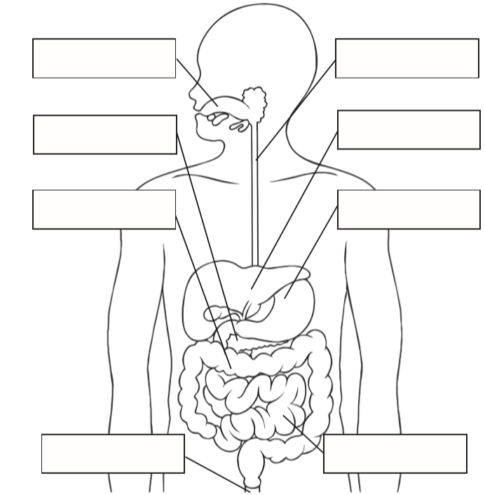

Oesophagus, liver, mouth, small intestine, large intestine, anus, pancreas, stomach

**Reading**

**LO: Use new vocabulary in sentences**

**Marine = from the ocean**

**Glide = to move smoothly**

**Delectable = looks or tastes amazing**

**Aquatic = growing or living in water**

**Frigid = incredibly cold**

**Torpedo = a missile that travels underwater from a submarine or boat**

**Fill in the missing words:**

1. **My friend’s ice-cream looked _____________________!**
2. **If I had known how _________________ the water was, I never would have jumped straight in!**
3. **Orca whales are ____________________ animals.**
4. **The penguin was like a _____________________________ when it dived into the water.**
5. **Lily pads are _________________________ plants.**
6. **I watched a pod of dolphins _____________________ through the ocean.**

**Challenge: Write some interesting sentences of your own using the vocabulary above.**

**Numeracy**

**LO: Be able to use my 7 times tables**

**We would have been focusing on the 7 times tables today.**

**Write out all of your 7 times tables**

**e.g. 1 x 7 = 7**

**2 x 7 = 14**

**then answer the following:**

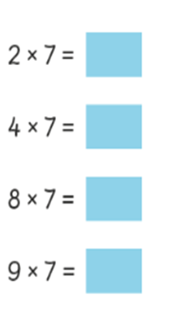

**Support Idea**

**Connect pieces of lego together to make multiples of 7**

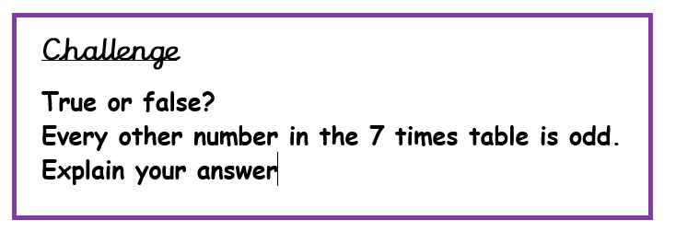

**Remember odd numbers end in 1, 3, 5, 7 or 9!**

