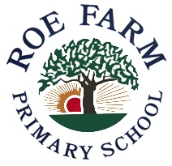
Worcester Crescent, Chaddesden, Derby. DE21 4HG
01332 346310
admin@roefarm.derby.sch.uk
www.roefarmprimary.co.uk
Head Teacher: Mrs H Weston
Together we make a difference!
July 2020

Dear Parents and Carers
Further guidance was published last week, outlining that all children will be expected to return to school in September. We have been working hard to look at the safest possible ways to bring your children back. As before, there have been a number of factors that have had to be carefully considered to minimise risks to both staff and children.
There is no question at all about us wanting to welcome your children back in school but our priority is to ensure it is safe. We can by no means guarantee that there are no risks but we have taken every possible step to minimise risks under the current guidance around social distancing and maintaining high standards of hygiene and cleanliness in school.
I want to emphasise to you that your child’s classroom space will be very different to when they finished in March due to the guidance in place. However, we will do everything we can to continue to provide the best opportunities in these difficult situations and ensure they feel safe, secure and ready to learn.
First and foremost, your child will be reminded at regular intervals throughout the day to wash their hands. There are handwashing facilities in all classrooms for your child to access. Cleaning schedules have also been reviewed to ensure regular cleaning of areas throughout and at the end of each day.
Your child is in Year 6 and the organisation will be as follows:
- Children will be in school every day: Monday to Friday
- There will be no breakfast club running
- School day: 8.45am – 3.00pm. Please ensure prompt collection to allow for the playground to be cleared for the next groups of children to leave.
- Parents will be allowed onto the playground but there will be designated areas for you to stand in whilst observing the 2m social distancing rule where possible.
- Arrival to and exit from school: St Andrew’s View
Top gate: Year 6
- Your child will return to the new class teacher as stated on their school report.
- Children will be in year group bubbles throughout the day to reduce the risks of contamination.
- Your child will have their own set of stationery and books on their work - station.
- Children will sit in rows facing the front of the classroom rather than facing one another as this is something stipulated in the guidance (see below for an example).
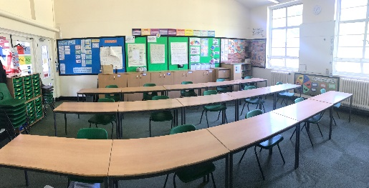
- Lunchtime and break times will be staggered and your child will remain in their ‘bubble’ with the same children and staff.
- Children will not mix with other children in other year groups.
- The playground will be zoned for each year group to play in.
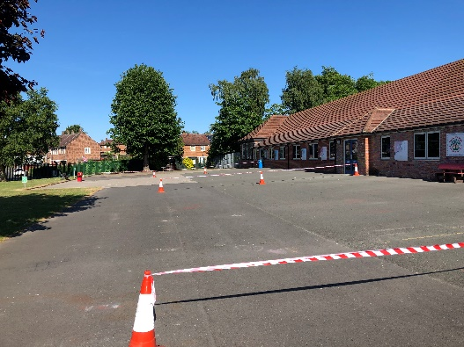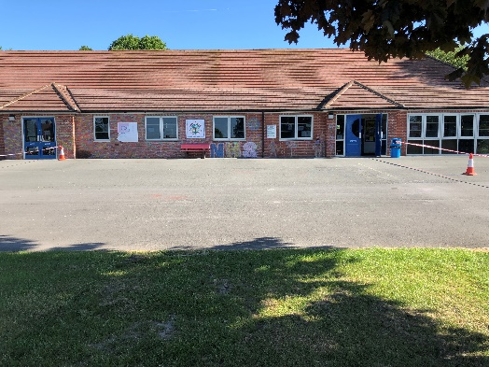
- If your child is ‘Free School Meals’ they child will be provided with a packed lunch in school unless you decide to send them with one from home.
- Free School meal vouchers will no longer be available if you are currently receiving them.
- Your child will be eating dinner in their classroom and hot meals will not be provided. This will limit movement and reduce risks
- Children will be expected to wear full school uniform.
- Attendance in school is crucial and a legal obligation. If your child does not attend fines will be issued.
- Please avoid bringing/sending your child to school with any extra bags, pencil cases etc. to reduce the risk of contamination.
- Children will be given everything they need in school and will not be able to use items from home.
If your child shows symptoms during the school day, you will be contacted to collect your child immediately.
There will be an expectation that your child is tested and we ask that you update school as soon as results are received.
PLEASE ENSURE WE HAVE ALL UP TO DATE CONTACT NUMBERS IN CASE OF AN EMERGENCY!
Although these measures are in place and children will be encouraged to social distance this cannot always be guaranteed, particularly with younger children. In addition to this, any measures we put in place will simply reduce risk not eliminate risk, as mentioned previously.
Children will return to school on Friday 4th September. Please keep an eye on the school website or dojo for further updates and information.
If you have any questions or queries please do not hesitate to contact me. Thank you for your continued support and understanding.
Take care and stay safe everyone!
Yours sincerely
H Weston

Head teacher

