Education Child Protection/Safeguarding Policy

Name of school: Roe Farm Primary School

Date of policy publication: TBC

Author/s of policy: Scott Wood, Helen Weston

Date of last review: January 2019 Date of next review: January 2021

Policy review dates and changes
Review date | By whom | Summary of changes made | Date implemented
October 2019 | HW/SW | Changes made inline with DSCB recommendations | November 2019

Contents | Page
1. Introduction | 3
- Policy aims
- Context
- Principles

2. Safeguarding Roles and Responsibilities of School/College Staff | 6
- Roles and responsibilities of Governors/trustees
- Roles and responsibilities of the Head teacher
- The Roles and responsibilities of the Designated Safeguarding Lead (DSL)
- Roles and responsibilities of other School Staff
- Named Roe Farm Primary School staff with specific safeguarding responsibilities
- Other key local and national safeguarding contacts

3. Environment – children are safe and feel safe | 13
- Safeguarding as part of the curriculum
- Vulnerable children
- Working with parents and carers

4. Taking Action on Concerns | 16
- Derby and Derbyshire Safeguarding Children Partnership procedures
- If you suspect a child has emerging needs, complex/serous needs or there are child protection concerns
- If information is disclosed to you
- Role of the Designated Safeguarding Lead (DSL) following identification of needs or concerns
- Notifying parents
- Getting early help for the child
- Referral to Children's Social Care
- Action following referral
- Confidentiality, sharing information and record keeping
- Support for those involved in a safeguarding/child protection issue

5. Peer on Peer/Child on Child Abuse/Allegations of Abuse made against other Children | 24
- What is peer on peer/child on child abuse?
- Actions school will take
- Action on concerns

6. Safer Recruitment and Selection of Staff | 27
- 'Extended school' and off site arrangements
- School visitors

7. What staff should do when they have concerns about another staff member (including volunteers) | 28
- If you have concerns about a colleague
- Initial actions following an allegation
Appendices
- Types of abuse and possible indicators | 30
- Concerns form | 34
- Actions where there are concerns about a child flowchart | 36
- Body maps | 37
- What is Domestic Abuse, so called ‘Honour Based Violence’ (HBV) Female Genital Mutilation (FGM) and Forced Marriage? | 42
- Privately Fostered Children or Young People and flowchart | 47
- Radicalisation and Extremism | 49
- Criminal Child Exploitation; county lines | 51
- The Seven Golden Rules to Sharing Information | 52
- Role of Designated Safeguarding Lead (DSL) and deputy | 53
- Guidance and further information | 56

1. Introduction

Roe Farm Primary School recognises that we have an important role to play in multi-agency safeguarding arrangements. We are committed to safeguarding children and young people and expect everyone in our school to share this commitment.

This document outlines Roe Farm Primary School’s child protection / safeguarding policy. It applies to all adults, including volunteers working in or on behalf of the setting.

Child protection is defined as safeguarding and promoting the welfare of children by:
- Protecting children from maltreatment;
- Preventing impairment of children’s health or development;
- Protecting children from the risk of radicalisation, exploitation and other harms e.g. drugs, alcohol, gangs, neglect, serious violent crime, sexual or criminal (including county lines) exploitation;
- Ensuring children grow up in circumstances consistent with the provision of safe and effective care; and
- Taking action to enable all children to have the best outcomes.

Everyone working in, or for our school, takes all welfare concerns seriously and encourages children and young people to talk to us about anything that worries them. We share an objective to help keep children and young people safe by contributing to;
- Providing a safe environment for children and young people to learn in education settings;
- Creating a culture of vigilance where we always act in the best interests of the child;
- Identifying children who may be at risk of radicalisation, in need of extra help, or are suffering or likely to suffer significant harm, and taking the appropriate action, working with other services as needed.

We will ensure that parents and our partner agencies are aware of our child protection/ safeguarding policy by ensuring that it is displayed in the reception area, by raising awareness at initial meetings with parents of new pupils and at parent teacher meetings and ensuring that it is on the school website. The school website will also have information about how parents/children/other agencies can contact the Designated Safeguarding Lead (DSL) and their deputy and include their availability in school holidays.

Policy Aims
The aim of this policy is to outline how the school will:
- Promote a positive school ethos where children can learn, feel secure and be safe.
- Prevent unsuitable people working with children and young people.
- Promote safe practice and challenge poor and unsafe practice.
- Identify instances in which there are grounds for concern about a child's welfare, and initiate or take appropriate action to keep them safe.
- Contribute to effective partnership working between parents and all those involved with providing services for children and young people.

The policy will be reviewed annually as a minimum, unless an incident or new legislation or guidance suggests the need for an earlier date of review.

Context
This policy enables Roe Farm Primary School to carry out our functions with a view to safeguarding and promoting the welfare of children under sections 175 and 157 of the Education Act (2002).

Due to the context of our school, our children may be at greater risk of neglect and/or witnessing domestic abuse incidents and the emotional impact this has on them. In order to protect our pupils we are part of the ‘Stopping Domestic Abuse Together Initiative’, furthermore all of our staff are trained annually to raise awareness of Prevent; during this training, we also highlight and discuss the possible signs and symptoms of our identified higher risk abuse categories. Due to the nature of our community and the context of our school, our curriculum covers a number of elements relating to how our children can keep themselves safe and protect themselves from harm. Links have been developed with partner agencies in order to raise awareness and provide pupils with the necessary tools to communicate concerns.

The policy is in line with the following legislation and guidance:
- Working Together to Safeguard Children (2018)
- The Children Act (1989) and Children Act (1989)
- Keeping Children Safe in Education (Sept 2019)
- Information Sharing: Advice for practitioners providing safeguarding services to children, young people, parents and carers (2018)
- Protection of Freedoms Act (2012)
- Data Protection Act (2018)
- The Prevent Duty Guidance for England and Wales (2015)
- The Prevent Duty: departmental advice for schools and childcare providers (2015)
- Prevent Duty Guidance: for further education institutions in England and Wales (2015)
- Mandatory reporting of Female Genital Mutilation – procedural information (2015)
- Sexual Offences Act (2003) and Serious Crime Act (2015)
- Sexual violence and sexual harassment between children in schools and colleges (2018)
- Children Missing Education; statutory guidance for local authorities (2016)
- Mental Health and Behaviour in Schools (2018)
- Relationships Education, Relationships and Sex Education (RSE) and Health Education (2019)
- Teaching Online Safety in Schools (2019)
- Serious Violence Strategy (2018)
- Promoting the education of looked-after children and previously-looked after children; Statutory guidance for local authorities (2018)
- Designated teacher for looked-after and previously looked-after children (2018)

The policy is consistent with Derby and Derbyshire Safeguarding Children Partnership web-based procedures, including the local criteria for action (thresholds document) and local protocol for assessment. These can be found on the school website and is also located on the Policy and Procedures page of www.ddscp.org.uk. The school will adhere to the Derby and Derbyshire Safeguarding Children Partnership procedures.

Multi-agency working
The safeguarding partners in Derby and Derbyshire have a shared and equal duty to make arrangements to work together to safeguard and promote the welfare of all children in a local area. The local area safeguarding partners are Derby City Council, Derbyshire County Council, Derbyshire Constabulary, Derby and Derbyshire Clinical Commissioning group and Tameside and Glossop Clinical Commissioning group. The partners will agree on ways to co-ordinate their safeguarding services, acting as a strategic leadership group in supporting and engaging others and implementing local and national learning including from serious child safeguarding incidents. Roe Farm Primary School will work in partnership with the Derby and Derbyshire Safeguarding Children Partnership (DDSCP) and follow relevant local arrangements as published. See Derby and Derbyshire Safeguarding Children Partnership plan for new arrangements. Local schools and colleges are named as relevant agencies by the DDSCP and as such we will be under a statutory duty to co-operate with the published arrangements.

Safeguarding is not just about protecting children from deliberate harm, neglect or failure to act, it relates to aspects of broader aspects of care and education. This policy therefore complements and supports a range of other school policies, such as, but not exclusively;
- Health and safety
- Behaviour management, including mental health and behaviour, bullying/ online bullying and prejudice-based bullying as well as the use of reasonable force/physical intervention, including the increased vulnerability of children with special education needs (SEN) or disabilities and equality duties
- Meeting the needs of pupils with medical conditions
- First aid
- Educational visits
- Intimate care
- Online safety and other associated issues, including sexting/‘youth produced sexual imagery’, use of pupil mobile phones in school and appropriate filtering and monitoring, including how children can be kept safe from terrorist and extremist material
- Safer recruitment and selection, including single central record
- School security and visitors
- Managing allegations against staff, including volunteers and incorporating ‘duty to refer’
- Attendance
- Children who runaway or go missing from education, home or care
- Staff behaviour (code of conduct)
- Agreement for visiting speakers
- SEND
- Relationships education(RE)/relationships and sex education (RSE) and health education (physical and mental well-being)
- Communication
- Complaints procedure
- Information sharing
- Whistle blowing

Principles
Safeguarding arrangements in the school are underpinned by the 2 key principles:

- Everyone who comes in to contact with children and their families has a role to play in safeguarding children. All Governors, staff, trainees and volunteers have a responsibility and role to identify concerns, share information appropriately and take prompt action. Staff members will maintain an attitude of “it could happen here” where safeguarding is concerned.

- When concerned about the welfare of a child, staff will always act in the best interests of the child. The school operates a child centred approach taking into account children’s views and voices. The child’s wishes and feelings will be taken into account when determining what action to take and services to provide to protect individuals children through ensuring there are systems in place for children to express their views and give feedback.
2. Safeguarding Roles and Responsibilities of School Staff

All adults working in, or on behalf of the school have a responsibility to safeguard and promote the welfare of children and prevent radicalisation and extremism. This includes;
- Responsibility to provide a safe environment in which children can learn.
- Creating a culture of vigilance where we always act in the best interests of the child.
- Taking all welfare concerns seriously and encouraging children and young people to talk to us about anything that worries them.
- To identify children who may be in need of extra/early help, have complex or serious needs or who are suffering, or are likely to suffer significant harm. All staff then have a responsibility to take appropriate action, working with services as needed.

Staff induction will include organisation vision, aspirations and expectation of all staff as well as what is considered acceptable and what is not. They will also receive information about systems within the school, which support safeguarding and paper/electronic copies of policies; this includes the child protection/safeguarding policy, school behaviour policy, and staff behaviour policy (code of conduct). Staff will be informed about the safeguarding response to children who go missing from education and the role and names of the designated safeguarding lead (DSL), their deputy/ies and the name of the designated governor.

All staff will:
- Receive a paper/electronic copy of, read and sign to say that they have received, read and understood Keeping Children Safe in Education: for school and college staff (part 1) (2019). School leaders, including Governors/Trustees and all those who work directly with children will read Keeping Children Safe in Education (2019).
- Receive safeguarding training which is regularly updated as well as Prevent Duty and online safety training, including sexting/‘youth produced sexual imagery’, so they are equipped with the knowledge and skills to keep children safe.
- Receive regular safeguarding and child protection updates at least annually via email, e-bulletins and staff meetings to help provide them with an awareness of safeguarding issues that can put children at the risk of harm (including private fostering arrangements, drug taking, alcohol abuse, family members in prison, deliberately missing education, homelessness, sexting also known as ‘youth produced sexual imagery’, ‘honour based’ abuse/violence including FGM and forced marriage, sexual exploitation, serious violent crime, criminal exploitation/county lines, peer on peer / child on child abuse and radicalisation/extremism), ensuring they have the relevant skills and knowledge to safeguard children effectively.
- Not assume a colleague or another professional will take action and share information that might be critical in keeping children safe.
- Be mindful that early information sharing is vital for the effective identification, assessment and allocation of appropriate service provision.
- Be aware of;
  - The ‘Stopping Domestic Abuse Together’ initiative, a police lead early domestic abuse notification to schools;
  - The safeguarding response to children who go missing from education;
  - The early help process for low level and emerging needs and understand their role in it;
  - The process for making referral to Children’s Social Care and for statutory assessments that may follow this and the role they may play in such assessments.
- Do everything they can to support Social Workers.
- Know what to do if a child tells them about welfare concerns or that he/she is being abused or neglected and how to share information appropriately only involving those who need to be involved such as the designated safeguarding lead (or a deputy) and social care.
- Know what to do if a child shares, produces or receives a sexual communication, including sexting /‘youth produced sexual imagery’.
- Be aware that children are capable of abusing their peers, that support is needed for victims and perpetrators and be clear about the school policy and procedures on peer on peer / child on child abuse. Staff have been trained so that they understand how to handle reports of sexual violence and harassment between children, on and outside school premises. See Section 5 Peer on Peer / Child on Child Abuse.
- Know that children’s poor behaviour may be a sign that they are suffering harm or that they have been traumatised by abuse.
- Know that safeguarding incidents and/or behaviours can be associated with factors outside the school and/or can occur between children outside the school and consider the context within which such incidents and/or behaviours occur. This is known as contextual safeguarding, simply meaning that assessments of children will consider whether wider environment factors are present in the child’s life that are a threat to their safety or welfare.

We will engender the principle that safeguarding is 'everyone's responsibility'.

All staff and volunteers should raise any concerns they have about poor or unsafe practice and potential failures in the school safeguarding regime. These concerns will be taken by the senior leadership team. See the school ‘Whistleblowing Procedures’ for how such concerns can be raised with the Senior Leadership Team and the other whistleblowing channels open to staff.

Roles and Responsibilities of Governors
The Governing Body has the responsibility to ensure that the school complies with safeguarding duties under legislation and will identify a senior board level lead to take leadership responsibility for the establishment’s safeguarding arrangements. Safeguarding is a standing item at all governing body meetings.

The Governing Body will ensure that:
- The school contributes to inter-agency working in line with Working Together to Safeguard Children (2018) by:
  - Providing a co-ordinated offer of early help when low level or emerging needs of children are identified;
  - Contributing to inter-agency support to children subject to child in need or child protection plans; and
  - Allowing access for Children’s Social Care to conduct or consider conducting an assessment.
- They have awareness of local arrangements and a good understanding of the school role in the new Derby and Derbyshire Safeguarding Children Partnership arrangements.
- They understand the local Threshold document which sets out the criteria for action, child protection conference professional dissent policy, escalation policy and the local protocol for assessment.
- The importance of information sharing between professionals and local agencies is recognised as key in promoting the welfare and protecting the safety of children. Arrangements are in place that set out clearly the process and principles for sharing information within the school, with the Derby and Derbyshire Safeguarding Children Partnership and other agencies and practitioners as required.
- There is awareness and due regard to the obligations of the Data Protection Act 2018 and GDPR to ensure that personal information is processed fairly and lawfully and kept safe and secure and where appropriate is shared to support the safeguarding of children and individuals at risk. Fears about sharing information must not be allowed to stand in the way of the need to promote the welfare and protect the safety of children.
- The school’s safeguarding arrangements take into account procedures and practice of the local authority as part of the inter-agency safeguarding procedures set up by Derby and Derbyshire Safeguarding Children Partnership (DDSCP). This includes co-operation between partner agencies and providing information to the DDSCP to allow it to perform its functions.
- The Chair of the Governing body will liaise with the Local Authority Designated Officer (LADO) (also known as Designated Officer) and partner agencies in event of any allegations of abuse made against the head teacher.
- There is an effective safeguarding/child protection policy which is consistent with Derby and Derbyshire Safeguarding Children partnership procedures, including the local criteria for action (thresholds document) and local protocol for assessment, along with a school behaviour policy and staff behaviour policy (code of conduct). This will be provided to all staff on induction, will be updated annually as a minimum and available on the school website along with the contact details of the Designated Safeguarding Lead, their deputy/ies and their availability, including during school holidays.
- The safeguarding/child protection policy includes procedures which minimise the risk of peer on peer / child on child abuse, how allegations will be investigated and dealt with and have clear processes as to how victims, perpetrators and any other child affected by peer on peer / child on child abuse with be supported.
- All policies and procedures adopted by governing bodies/Trustees, particularly concerning referrals of suspected abuse and neglect, are followed by all staff.
- All staff including governors/trustees and volunteers adhere to their duties in The Prevent Duty (2015) to prevent radicalisation. Keeping children safe from these risks is a safeguarding matter and should be approached in the same way as safeguarding children from other risks.
- There is a whole school approach to domestic abuse and this includes active participation in the police led ‘Stopping Domestic Abuse Together’ (SDAT) initiative.
- A member of the Senior Leadership Team is appointed to the role of Designated Safeguarding Lead (DSL); this will be explicit in the role holder’s job description, have the appropriate authority and given time, funding, training, resources and support to fulfil their role effectively. A Designated Deputy Safeguarding Lead, explicit in the role holder’s job description, will also be appointed in the same way and can be delegated the activities of the Designated Safeguarding Lead; however the lead responsibility for safeguarding remains with the DSL.
- All staff members undergo safeguarding and child protection training at induction.
- The Designated Safeguarding Lead (DSL) and their deputy undergo training at a minimum every two years and their knowledge and skills are updated at least annually to keep up to date with developments relevant to their role.
- The Head teacher and other staff will undergo child protection training regularly and will receive safeguarding and child protection updates at least annually to provide them with relevant skills and knowledge to safeguard children effectively.
- Staff training will be consistent with the Derby and Derbyshire Safeguarding Children Partnership guidance Training Pathways for Education Providers. See DDSCP Training Courses and Events page.
- There is a whole school approach to online safety to address the 3 areas of risk; content, contact and conduct. This includes a policy on the use of mobile technology in the setting, appropriate filters and monitoring systems to ensure children are safeguarded from potentially harmful and inappropriate material online, including terrorist and extremist material, as well as online safety training for staff. As technology in this area evolves and changes rapidly online safety will be regularly reviewed.
- Ensure that children are taught about safeguarding, including mental health/well-being and online safety (this incorporates healthy online/offline relationships, sexting/‘youth produced sexual imagery’ and terrorist/extremist material), through teaching, learning opportunities and tutorials.
- People who pose a risk of harm are prevented from working with children by:
  - Adhering to statutory responsibilities to check staff working with children, taking proportionate decisions on whether to ask for checks beyond what is required and ensuring volunteers are appropriately supervised.
  - Having a written recruitment and selection policies and procedures in place.
  - The presence of at least one person on any appointment panel who has undertaken safer recruitment training.
- There are procedures in place to handle allegations of abuse against staff and volunteers and that such allegations are referred to the Local Authority Designated Officer (LADO)/Designed Officer at the local authority and that procedures are in place to make a referral to the Disclosure and Barring Service (DBS) when the criteria has been met. There are also procedures in place to handle allegations of abuse by children against other children also known as ‘peer on peer abuse’ or ‘child on child abuse’.
- There are systems in place for children to report any concerns, express their views and feedback. Staff will not agree confidentiality and will always act in the best interests of the child.
- A Designated Teacher with the appropriate training, relevant qualifications and experience will be appointed to promote the education achievement of children who are Looked After or previously Looked After. All staff will have the skills, knowledge and understanding to keep Looked After children and previously Looked After children safe.
- There are appropriate safeguarding responses to children who go missing from education, particularly on repeat occasions and this is consistent with DfE Children Missing Education guidance, Derby City Council Children Missing Education Policy and Derby and Derbyshire Runaway or Missing from Home or Care Protocol.
- Where reasonably possible ensure that the school hold more than one emergency contact number for each pupil.
- Ensure exclusions internal, fixed term and permanent meet requirements of DfE statutory guidance, including obligations under the Equality Act (2010).
- Any deficiencies or weaknesses in regard to safeguarding arrangements that are brought to their attention are addressed without delay.

Roles and Responsibilities of the Head teacher
The Head teacher will ensure that:
- They have awareness of local arrangements and a good understanding of the school role in the new Derby and Derbyshire Safeguarding Children Partnership arrangements.
- The policies and procedures adopted by the Governing Body, particularly concerning referrals of cases of suspected abuse and neglect, are fully implemented and followed by all staff.
- Sufficient time and resources are allocated to enable the Designated Safeguarding Lead (DSL), their deputy and other staff to discharge their responsibilities, including recording and monitoring safeguarding activities, taking part in strategy discussions/meetings, other inter-agency meetings and contributing to the assessment of children.
- All staff and volunteers feel able to raise concerns about poor or unsafe practice with regard to children, and concerns are addressed sensitively and effectively in a timely manner.
- The child's safety and welfare is addressed through the curriculum. This includes building pupils’ resilience to radicalisation by promoting fundamental British values and enabling them to challenge extremist views.
- Education Welfare Staff and Social Workers are informed immediately when a child who is Looked After or subject to a Child in Need plan or a Child Protection plan goes missing. See Derby and Derbyshire Runaway or Missing from Home or Care Protocol.
- The school fulfils the requirements of DfE Children Missing Education guidance, and Derby City Council Children Missing Education policy, including those related to elective home educated children.
- Ensure exclusions internal, fixed term and permanent meet requirements of DfE statutory guidance, including obligations under the Equality Act (2010). They undertake appropriate training to carry out their safeguarding responsibilities effectively and keep this up-to-date.

The Roles and Responsibilities of the Designated Safeguarding Lead (DSL)
The Designated Safeguarding Lead (DSL) is a senior member of staff who co-ordinates the setting’s safeguarding and child protection arrangements by providing advice and support to other staff on child welfare and child protection matters, ensures Stopping Domestic Abuse Together notifications are appropriately actioned, takes part in strategy discussions/ meetings and inter-agency meetings – and /or supports other staff to do so - and contributes to the assessment of children.

The Designated Safeguarding Lead (DSL) liaises with the local authority and works with other agencies in line with Working Together to Safeguard Children (2018). Where there are serious/complex needs or child protection concerns, this includes referrals to Children’s Social Care, the Police and Channel. In exceptional circumstances, i.e. in an emergency or concern that appropriate action hasn’t been taken, staff members can speak directly to Children’s Social Care.

The Designated Safeguarding Lead (DSL) has an awareness of local arrangements and has a good understanding of the school role in the new Derby and Derbyshire Safeguarding Children Partnership arrangements.

The establishment also has a deputy Designated Safeguarding Lead (DSL) to cover for when the Designated Safeguarding Lead (DSL) is not available; the lead responsibility however remains with the Designated Safeguarding Lead.

During term time, the Designated Safeguarding Lead (DSL) and / or a deputy will be available during school hours for staff to discuss safeguarding concerns. Adequate and appropriate cover arrangements will be made for any out of hours/out of term activities.

The Designated Safeguarding Lead and/or their deputy will also be involved in anything safeguarding related in the content of relationships education/relationships and sex education and health education. In addition, the Designated Safeguarding Lead will also work in partnership with the Designated Lead for Mental Health to ensure that there is an effective and consistent whole school approach for children who may be at risk of abuse or neglect and/or who may need support with their mental health.

See appendix 10 for further information about the Role of the Designated Safeguarding Lead (DSL) and Deputy.

Roles and Responsibilities of other School Staff
If staff have any concerns including emerging needs, complex/serious needs or child protection concerns they must be discussed with the Designated Safeguarding Lead (DSL) or their deputy to agree a course of action.

If staff members are unsure they should always speak to the Designated Safeguarding Lead (DSL) or their deputy to clarify the situation and agree if any action is needed. Staff have a responsibility to promptly record all concerns using CPOMS (in the unlikely event that CPOMS is offline staff will use the concerns form) and forward this to the Designated Safeguarding Lead (DSL) or their deputy. All staff will work with the Designated Safeguarding Lead (DSL) and where appropriate support Social Workers to take decisions about individual children.

All staff, including volunteers and temporary staff must have an understanding of how the school safeguards and promotes the welfare of children, including the safeguarding/ child protection policy, their role and responsibilities in this and how to report any concerns.

Named Roe Farm Primary School staff with specific safeguarding responsibilities

- Name of Designated Safeguarding Lead: Helen Weston (Head Teacher)
  - Email details: head@roefarm.derby.sch.uk
  - Call: 01332 346310

- Name/s of deputy Designated Safeguarding Lead :
  - Matthew Davenport (Deputy Head teacher)
  - Scott Wood (Learning Mentor)
  - Jake Nicholas (Year 3-4 Team Leader)
  - Email: safeguarding@roefarm.derby.sch.uk
  - Call: 01332 346310

- Other staff with safeguarding responsibilities:
  - Dean Fitzgerald (Computer & E-safety Coordinator)
  - Contact: 01332 346310

- Name of Designated Governor: (Nicola Smith)
  - Contact details: (01332 346310)

- Name of Designated Teacher for Looked After /previously Looked After Children: (Matthew Davenport – Deputy Head teacher)
  - Contact details: (01332 346310)

- Designated Lead/s for Mental Health and Well-being
  - Contact details: Helen Weston (Head@roefarm.derby.sch.uk)

- Governor for Mental health and Well-being
  - Contact details: Nicola Smith (01332 346310)

Other Key Local Safeguarding Contacts

- Children's Social Care
  - Children's Services Professional Consultation Line 07812 300329
  - First Contact Team for urgent referrals 01332 641172
  - Derby Children's Social Care Online Referral system for non-urgent referrals
  - Careline (out of hours service) 01332 786968
  - Locality Vulnerable Children Meeting (VCM) for non-urgent social care referrals and requests for targeted early help via multi-agency team (MAT) via Locality Based Single Point of Access (SPA) Clerks:

    - Locality 1 and 5
Derwent, Chaddesden, Spondon, Oakwood, Mackworth, Allestree and Darley
Tel: 01332 642656
Email: vcm1and5@derby.gov.uk

    - Locality 2
Sinfin, Alvaston, Boulton, Chellaston, Osmaston and Allenton
Tel: 01332 641011
Email: vcm2@derby.gov.uk

    - Locality 3 & 4
Balgreaves, Littleover, Mickleover, Normanton and Abbey
Tel: 01332 641148
Email: vcm3and4@derby.gov.uk

    - The Light House (Integrated Disabled Children's Service) Single Point of Access Clerk
Tel: 01332 256990
Email: VCM-IDCS@derby.gov.uk

- Local Authority Designated Officer (LADO) 01332 642376

- Derbyshire Police 999 for emergencies or
101 for non-emergencies

- Channel/Prevent (radicalisation/extremism) Police Prevent Team on 101

- Female Genital Mutilation (FGM) mandatory reporting via Police on 101

- School Police link officer Derwent Ward Community Officers

- Public Health Nurse/other health contact (Cara Elliot: 01332 288773)

- Education Welfare/ Local Authority Children Missing Education Officer:
01332 641448 or educationwelfare@derby.gov.uk
Children Missing Education, including online referral form (form 13) to CME Officer
Notification of child on roll online form (form 15)
Notification of removal from roll online form (form 11)
Notification of Removal from roll to Elective Home Education (EHE) online form (form 12)

- Locality Multi-agency Team (MAT), Early Help Advisor, and Education Welfare Officer Gino Difusco (EWO – 01332 641456)
Cath Brannan (Early Help Advisor - 01332 641074)
Michelle Astle (Under 11’s MAT manager 1&5 – 01332 642225)

Key National Contacts

- NSPCC
  - NSPCC helpline - helping adults protect children 24 hours a day. For help and support, including anyone needing advice about female genital mutilation, young people affected by gangs, concerns that someone may be a victim of modern slavery contact the NSPCC trained helpline counsellors on:
    - help@nspcc.org.uk
    - Text 88858
    - 0808 800 5000

  - NSPCC Whistleblowing Advice Line - free advice and support for professionals concerned about how child protection issues are being handled in their organisation.
    - 0800 028 0285
    - help@nspcc.org.uk

- UK Safer Internet Centre professional advice line - helpline for professionals working with children and young people in the UK with any online safety issues they may face themselves or with children in their care.
  - helpline@saferinternet.org.uk
  - 0844 381 4772

- Police Anti-Terrorist Hot Line number 0800 789 321

3. Safe Environment – children are safe and feel safe

Roe Farm Primary School adopts an open and accepting attitude towards children as part of our responsibility for pastoral care. Children, parents and staff will be free to talk about any concerns and will see the setting as a safe place when there are difficulties. Children's worries and fears will be taken seriously and children encouraged to seek help from school staff.

Roe Farm Primary School will therefore ensure that:
- There is an ethos where children feel secure and are encouraged to talk and are listened too, taken seriously and responded to appropriately is established and maintained.
- Children are involved in the decision-making which affects them.
- Children know that there are adults in the school whom they can approach if they are worried or have difficulties and the setting has well developed listening systems.
- Posters are displayed which detail contact numbers for appropriate support services and child protection helplines i.e. Childline.
- Curriculum activities and opportunities to equip children with the resilience and skills they need to stay safe from abuse and radicalisation.
- There is a clear written statement of the standards of behaviour and the boundaries of appropriate behaviour expected of staff and pupils that is understood and endorsed by all.
- There is an awareness that adverse childhood experiences (ACES)/trauma and other events may have an impact on children and that they may require additional support. Positive and safe behaviour is encouraged among children and staff are alert to changes in a child’s a behaviour and recognise that challenging behaviour and mental health problems may be an indicator of abuse or neglect.
- Effective working relationships are established with parents and colleagues from partner agencies.
- There is awareness that there may be wider environmental factors present in a child’s life that are a threat to their safety and welfare (contextual safeguarding). For example personal and family circumstances and lifestyles of some children lead to an increased risk of neglect and or abuse. In particular staff are knowledgeable about private fostering arrangements, family members in prison, homelessness, domestic violence, ‘honour based’ abuse/violence including female genital mutilation (FGM) and forced marriage, online safety, hate crime, radicalisation, serious violence crime, child exploitation (sexual and criminal/county lines) also known as child at risk of exploitation (CRE) and peer on peer / child on child abuse such as sexual violence and harassment.
- There is a recognition that children who do not attend regularly or go missing from education are particularly vulnerable and at increased risk of neglect and abuse.
- Staff are appropriately trained in safeguarding according to their roles and responsibilities, have regular opportunities for safeguarding briefings and records are kept of all training undertaken.
- Safer recruitment procedures are used to make sure that all appropriate checks are carried out on staff (and volunteers) who work with children.
- Volunteers and visitors are appropriately supervised.
- The environment is safe and secure; this incudes ensuring the all visitors to the setting are suitable and checked and monitored as appropriate. The school “Visitors’ Policy” sets out how visitors will be checked and monitored. Also see DDSCP Access to Schools by Staff from Other Agencies Briefing Note.
- Where the school has invited external agencies in i.e. to support delivery of subjects such as online safety, relationships /relationships and sex education and health education, there will be an agreement made in advance of the session on how a safeguarding report should be dealt with by the external visitor.
- Any groups using school premises for the provision of services to children have their own safeguarding policies, or adopt the school policy, and have satisfactorily completed all appropriate checks.
- All visiting speakers present materials appropriate to the age and maturity level of pupils/students, that do not insult or promote intolerance of other faiths or groups, adhere to the school’s equalities policies and are not permitted to incite hatred, violence, call for the breaking of the law or promote any acts of terrorism or extremism.

Safeguarding as part of the Curriculum
We ensure that our pupils are taught about safeguarding, including online, through various teaching and learning opportunities, as part of providing a broad and balanced curriculum. Our learners are helped to talk about their feelings, know about their rights and responsibilities, understand and respond to risks, to deal assertively with pressures and know who they can turn to for advice and help both in and out of the school and how to make a complaint. This means that they are able to recognise when they are at risk and are able to get help when they need it.

The following areas are addressed within PSHE/Relationships Education/Relationships and Sex Education, Health education and in the wider curriculum:
- Bullying, including cyber-bullying
- Drugs, tobacco and alcohol use/abuse, including ‘new psychoactive substances/NPS’
- Online/e safety, including sexting/‘youth produced sexual imagery’
- Road, fire and water safety
- Physical health and mental well-being, including prevention i.e. fitness, healthy eating and sleep, basic first aid and changing adolescent body.
- Emotional well-being and mental health
- Relationships, including families, caring/respectful friendships, respectful, healthy offline/online and intimate relationships, being safe and the law
- Child exploitation, including child sexual exploitation (CSE) and child criminal exploitation/county lines (CCE) as known as child at risk of exploitation (CRE)
- So called ‘honour based’ abuse/violence and forced marriage
- Female genital mutilation (FGM)
- Hate crime, radicalisation and extremism

Vulnerable Children
We recognise that some children will be at increased risk of neglect and abuse, particularly those with special educational needs (SEN) and disability. Many factors can contribute to an increase in risk, including prejudice and discrimination, isolation, social exclusion, communication issues and reluctance on the part of some adults to accept that abuse happens, or who have a high level of tolerance in respect of neglect.

To ensure that all of our children receive equal protection, we will give special consideration and attention to children who are;
- Disabled or have special educational needs
- Living in a known domestic abuse situation
- Affected by known parental substance (drugs and/or alcohol) misuse
- Asylum seekers/refugees
- From our New Communities
- Living away from home, including private fostering arrangements
- Vulnerable to being bullied, or engaging in bullying
- Going missing from school, particularly on repeat occasions
- Are at risk of homelessness or living in temporary accommodation
- Living transient lifestyles
- Living in chaotic, neglectful and unsupportive home situations
- Vulnerable to discrimination and maltreatment on the grounds of race, ethnicity, religion gender or sexuality
- At risk of developing mental health problems, sexual exploitation and/or criminal exploitation (county lines) (also known as child at risk of exploitation/CRE), hate crime, serious violent crime, radicalisation, or so called honour based abuse/violence including forced marriage and female genital mutilation (FGM)
- Young carers
- Looked after Children and previously looked after children
- Not speaking or not having English as a first language
- Children in the court system
- Children with family members in prison.

Special consideration includes the provision of safeguarding information, resources and support services in community languages and accessible formats. Where appropriate this may also mean extra pastoral support. See the school SEND annual information report.

Working with parents and carers
We recognise the importance of working together with parents/carers to educate as well as safeguard and promote the welfare of children.

Roe Farm Primary School will ensure that;
- We work with parents positively, openly and honestly.
- Parents are encouraged to discuss their issues or concerns about safety and welfare of children, and they will be listened to and taken seriously.
- We will provide parents with information about safeguarding issues, such as child exploitation (sexual and criminal) known as child at risk of exploitation (CRE), mental health and online safety, including sexting/‘youth produced sexual imagery’ and terrorist/extremist material. We will also outline the support available to keep children safe within the school, locally and nationally.
- Up to date and accurate information is kept about pupils i.e.
  - names and contact persons with whom the child normally lives;
  - those with parental responsibility;
  - where reasonably possible hold more than one emergency contact number;
  - if different from the above those authorised to collect the child from the setting;
  - name and contact details of GP;
  - any relevant court orders or any other factors which may impact on the safety and welfare of the child.
- Information about pupils given to us by children themselves, their parents or carers or by other agencies will remain confidential. Staff will be given relevant information on a 'need to know' basis in order to support the child.
- Parents and carers are informed that the school is part of the ‘Stopping Domestic Abuse Together initiative’.
- It is made clear to parents and carers that the school has a duty to share information when there are any safeguarding concerns. Also that there is a duty to keep records which relate to safeguarding work by the school, or partner agencies. These will be kept securely, kept apart from the main pupil record and only accessible to key members of staff. Copies of these records will be securely sent to any education provider to which the child transfers.
- Where we have reason to be concerned about the welfare of child we will always seek to discuss this with the child's parents or carers first, however there may be occasions where we are not able to do this.

4. Taking Action on Concerns

Key points to remember for taking action are;
- In an emergency take the action necessary to help the child, for example, call 999.
- Do not assume a colleague or another professional will take action and share information that might be critical to keeping a child safe. Early information sharing is vital in keeping children safe.
- Report your concern to the Designated Safeguarding Lead (DSL) or their deputy as soon as you can and by the end of the day at the latest.
- If the Designated Safeguarding Lead (DSL) or their deputy is not around, ensure the information is shared with the most senior person in the school that day and ensure action is taken to report complex or child protection concerns to Children’s Social Care. Do not start your own investigation.
- If the concerns are about sexting/‘youth produced sexual imagery’ do not view, copy, print or share the images. Any relevant devices should be confiscated.
- Share information on a need-to-know basis only – do not discuss the issue with colleagues, friends or family.
- As soon as you are able complete a record of the concerns on CPOMS (In the unlikely event that CPOMS is offline concerns forms should be used and handed to the DSL or their Deputy). At the latest this should be on the same day and before the child is due to leave the school premises (see Appendix 2: Concerns Form).
- Seek support for yourself if you are distressed.

Note: All Stopping Domestic Abuse Together notifications will be treated as any other safeguarding concern.

All staff should follow the Derby and Derbyshire Safeguarding Children Procedures. These can be found in the school office or on the school website and are also located on the Policies and Procedures page of www.ddscp.org.uk. The Derby and Derbyshire Thresholds document will support the Designated Safeguarding Lead (DSL), their deputy and staff in their decision making about the child’s needs and the appropriate assessment and interventions.

It is not the responsibility of the school staff to investigate welfare concerns or determine the truth of any disclosure or allegation; this is the responsibility of Children's Social Care. All staff however have a duty to recognise where extra support is needed or where there are complex needs or child protection concerns requiring intensive or specialist support. Accordingly all concerns regarding the welfare of pupils will be recorded and discussed with the Designated Safeguarding Lead or their deputy (or another senior member of staff in the absence of the designated lead or deputy) prior to any discussion with parents.

See flow chart appendix 3 – reporting on concerns

If you suspect a child has emerging, complex needs or there are child protection concerns
Information about abuse and neglect can be found in Appendix 1. Please see Section 5 for further guidance on Peer on Peer / Child on Child abuse, Appendix 5 for additional information about domestic abuse, ‘honour based abuse/violence’ (HBV) including female genital mutilation (FGM) and forced marriage, Appendix 6 for information about private fostering, Appendix 7 for information about Radicalisation and Extremism and Appendix 8 Child Criminal Exploitation, including county lines.

There will be occasions when you suspect that a child may be at risk, but you have no ‘real’ evidence or that the child may need support with their mental health. The child’s behaviour and or appearance may have changed, their attendance at school may have reduced, their ability to concentrate and focus may have altered or you may have noticed other behavioural and or physical but inconclusive signs. In these circumstances, you should try to give the child the opportunity to talk. The signs you have noticed may be due to a variety of factors and it is fine to ask the child if they are alright or if you can help in any way.

Ensure you record ALL early concerns using CPOMS. If a child or adult does begin to reveal that a child is being harmed you should follow the advice in the section ‘If information is a disclosed to you’.

If information is disclosed to you
It takes a lot of courage for a child, parent, carer or other significant adult to disclose that they are worried or have concerns. They may feel ashamed, the abuser may have threatened what will happen if they tell, they may have lost all trust in adults, or they may believe, or have been told, that the abuse is their own fault.

If a child or adult talks to you about any risks to a child's safety or wellbeing you will need to let them know that you must pass the information on – you are not allowed to keep secrets. The point at which you do this is a matter for professional judgement. If you jump in immediately the child or adult may think that you do not want to listen, if you leave it till the very end of the conversation, they may feel that you have misled them into revealing more than they would have otherwise.

During your conversation with the child or adult:
- Allow them to speak freely, listen to what is being said without interruption and without asking leading questions.
- Keep questions to a minimum and of an open nature (TED questions tell me, explain, describe) i.e. 'can you tell me what happened?' rather than 'did x hit you?'
- Remain calm and do not over react – the child or adult may stop talking if they feel they are upsetting you.
- Give reassuring nods or words of comfort – ‘I’m so sorry this has happened’, ‘I want to help’, ‘This isn’t your fault’, ‘You are doing the right thing in talking to me’.
- Do not be afraid of silences – remember how hard this must be for the child or adult.
- Under no circumstances ask investigative questions – such as how many times this has happened, whether it happens to siblings too, or what do other family members think about all this.
- At an appropriate time tell the child or adult that in order to help them you must pass the information on.
- Do not automatically offer any physical touch as comfort; it may be anything but comforting to a child who has been abused.
- Avoid admonishing the child or adult for not disclosing earlier. Saying ‘I do wish you had told me about this when it started’ or ‘I can’t believe what I’m hearing’ may be your way of being supportive but they may interpret it that they have done something wrong.
- Tell the child or adult what will happen next. The child or adult may agree to go with you to see the Designated Safeguarding Lead. Otherwise let them know that someone will come to see or contact them before the end of the day.
- Report verbally to the Designated Safeguarding Lead (DSL) or Deputy DSL.
- Write up your conversation as soon as possible and hand it to the Designated Safeguarding Lead.
- Seek support if you feel distressed.

If you are unsure you should always have a discussion with the Designated Safeguarding Lead to agree the best way forward.

Staff must always immediately inform the Designated Safeguarding Lead (DSL) or their deputy if there is:
- Any suspicion that a child is injured, marked, or bruised in a way which is not readily attributable to the normal knocks or scrapes received in play.
- Any explanation given which appears inconsistent or suspicious.
- Any behaviour which give rise to suspicions that a child may have suffered harm.
- Any concerns that a child may be suffering from inadequate care, ill treatment, or emotional maltreatment.
- Any concerns that a child is presenting signs or symptoms of abuse or neglect.
- Any significant changes in a child’s presentation, including non-attendance.
- Any hint or disclosure of abuse about or by a child / young person.
- Any concerns regarding person(s) who may pose a risk to children e.g. living in a household with children present.
- Any concerns about sexting or ‘youth produced sexual imagery’ and/or where any adult appears to be sexually communicating (e.g. email, text, written note or verbally) with a child; see DDSCP Briefing Note Offence of Sexual Communication with a Child.
- Any concerns about peer on peer / child on child abuse; this should never be tolerated and passed off as banter, having a laugh, boys being boys or part of growing up (see Section 5).
- Information which indicates that the child is living with someone who does not have parental responsibility for them (this known as private fostering). See Appendix 6.
- Any concerns that a child is at risk of domestic abuse, honour based abuse/violence including forced marriage or female genital mutilation (FGM). See Appendix 5.
- Any concerns that a child is at risk of radicalisation. See Appendix 7.
- Any concerns about child sexual exploitation (see Appendix 1) or criminal exploitation, including county lines; this is also known as child at risk of exploitation (CRE) (see Appendix 8).
- Any concerns that a child or their parent/carer may be a victim of modern slavery (trafficked).

Role of the Designated Safeguarding Lead following identification of needs or concerns, including all Stopping Domestic Abuse Together notifications
The Designated Safeguarding Lead (DSL) will:
- Assess any urgent medical needs of the child.
- Consider whether the child has low level, emerging needs or complex/serious needs or if there are child protection concerns.
- Where appropriate use relevant national, local and education based assessment tools and guidance to support the identification of needs and decision making. For example:
  - School based records, assessments and chronologies, including any contextual factors
  - DDSCP Threshold document and safeguarding children procedures
  - Sexting in schools and colleges: responding to incidents and safeguarding young people (UKCCIS)
  - DfE Sexual violence and sexual harassment between child in schools and colleges (2018)
  - Brook Traffic Light Tool to support the identification of healthy and harmful sexual behaviour in children and young people
  - DDSCP Child at Risk of Exploitation (CRE) Toolkit
  - DDSCP Graded Care Profile for Neglect (GCP)
  - Domestic Violence Risk Identification Matrix (DVRIM)
  - Safelives DASH Risk Identification Checklist for when domestic abuse, ‘honour’- based violence and/or stalking are disclosed
  - Body Maps – see Appendix 4
  - Contextual safeguarding tools
- Check whether the child is currently subject to a Child Protection Plan, or has previously been subject to a plan, is Looked After, has Child in Need plan or an Early Help Assessment (EHA) or is open to a Multi-Agency Team (MAT) or known to another agency.
- Confirm whether any previous concerns have been raised by staff.
- Consider whether the matter should be discussed with the child's parents or carers or whether to do so may put the child a further risk of harm (see below).
- If unsure about the action to take, including that a child protection referral should be made, seek advice from Children's Social Care or another appropriate agency.
- If the concerns are about radicalisation or violent extremism, make a referral to Channel via the Police Prevent Team.
- Where the child has complex needs or where there are child protection concerns, refer as appropriate to Children’s Social Care or locality based Vulnerable Children’s Meeting (VCM).
- If a child is at risk of immediate harm, and/or where it is believed a criminal offence has been committed, refer to the Police.

Notifying parents
The school will normally seek to discuss any needs or concerns about a child with their parents or carers. This must be handled sensitively. Where an Early Help Assessment would benefit the child and their family the most appropriate member of staff should approach the parent/carer to take this forward. In situations where there are serious needs or child protection concerns the Designated Safeguarding Lead (DSL) will make contact with the parent or carer. However, if the setting believes that notifying parents could increase the risk to the child or exacerbate the problem, then advice will first be sought from Children’s Social Care.

Getting early help for the child
If a referral to Social Care is not considered appropriate, consideration should be made to what support the child and family needs. The school will consider what support could be offered within the setting via pastoral support processes or whether it may be useful to undertake an Early Help Assessment (EHA) to clarify the child's needs/strengths and the support required and/or make a referral for other services.

Full written records of the information that the Designated Safeguarding Lead (DSL) or deputy received, detailing the actions taken or not taken and the reasons for these will be made. See Derby Education Providers Safeguarding/Child Protection File Guidance.

Using the Early Help Assessment (EHA)
Where parents, carers or children tell us that they require support, or staff identify that there may be emerging needs and that services might be required an Early Help Assessment (EHA) is likely to be beneficial. In such cases staff will have an open discussion with the parents / carers and child about the support and services that might help and agree how they would be accessed.

Extra support (universal)
Where the school and another service i.e. Derby early help offer to schools , may be able to meet the needs, take swift action and prevent needs escalating, the Early Help Assessment (EHA) pre-assessment will be completed to identify and document the needs. This process may identify that an Early Help Assessment may be needed and the action to be taken.

Emerging needs
Where the child or parent are likely to require co-ordinated support from a range of early help services, or where there are concerns for a child's well-being or a child's needs are not clear, not known or not being met, staff should discuss the use of the Early Help Assessment with the child and /or their parents or carers. Where a multi-agency response is needed a Team Around the Family (TAF) should be formed to bring together practitioners from the different services so that they, along with the family, can work together to meet the child's needs. The Designated Safeguarding Lead (DSL) or deputy will generally lead on liaising with other agencies, setting up the inter-agency assessment as appropriate. Staff may be required to support other agencies and professionals in an early help assessment, in some cases acting as lead professional.

For more information about the Early Help Assessment process see the DDSCP Early Help webpage or DDSCP safeguarding children procedures; Providing early help.

If Early Help and/or other support are appropriate, the case should be kept under constant review. At each stage of the process where the child’s situation doesn’t appear to be improving and complex needs requiring intensive support (via Multi-Agency Team/MAT) or enduring complex needs (child in need) or child protection concerns are identified requiring specialist support, a referral to Children’s Social Care will be made. See below.

Referral to Children’s Social Care

If at any point there is a risk of immediate serious harm to a child a referral should be made to Children’s Social Care and/or the police immediately.

Anybody can make the referral

Where it is believed that there are urgent child protection concerns, the Designated Safeguarding Lead (DSL) or deputy will make a referral to Children’s Social Care by phone and follow this up in ‘writing’ via the Derby Children's Social Care Online Referral System. Non-urgent cases should be referred via the Derby Children's Social Care Online Referral System or via submission of an Early Help Assessment, or equivalent assessment, to the weekly Vulnerable Child meeting (VCM) in the relevant locality.

In exceptional circumstances, such as in an emergency or a genuine concern that appropriate action hasn’t been taken, any staff member can refer their concerns directly to Social Care however they should inform the Designated Safeguarding Lead (DSL) or deputy as soon as possible. See Derby and Derbyshire Thresholds document and Derby and Derbyshire Safeguarding Children; Making a referral to Children’s Social Care procedure.

If the referral is about a ‘known’ case of female genital mutilation (FGM), in addition to a referral to Social Care, the individual teacher also has a mandatory reporting duty; see Mandatory Reporting of Female Genital Mutilation; procedural information (2015). Under this duty, ‘known’ cases of female genital mutilation (FGM) where a girl under 18 informs the person that an act of female genital mutilation (FGM) has been carried out on her, or where physical signs appear to show that an act of female genital mutilation (FGM) was carried out, must be reported to the Police on 101. This is a personal responsibility in addition to the referral to Children’s Social Care and the professional who identifies female genital mutilation (FGM) and/or receives the disclosure should make the report by the close of the next working day.

Action following referral
The Designated Safeguarding Lead (DSL), their deputy or other appropriate member of staff will:
- Where a referral was made by phone follow up the referral in writing using the online referral system within 48 hours and attaching any existing assessment i.e. Early Help Assessment.
- Children’s Social Care should make a decision within one working day of the referral being made about what course of action they are taking and let the school know the outcome. If the information is not forthcoming, the Designated Safeguarding Lead (DSL) or another appropriate member of staff should follow this up.
- Maintain contact with the allocated Social Worker and support them or other agencies following any referral.
- Contribute to any strategy discussion or meetings.
- Support any Section 47 enquiries or statutory assessments that are carried out.
- Provide a report for, attend and contribute to any initial and review Child Protection Conference.
- Share the content of this report with the parent and if appropriate the child, prior to the meeting.
- Attend core group meetings for any child subject to a Child Protection plan or Child in Need meeting for any child subject to a Child in Need plan.
- Whenever there are concerns about the outcome of a Child Protection Conference use the Derby Child Protection Conference Professional Dissent Process.
- Where a child on a Child Protection plan, Child in Need plan or who is Looked After moves from the school or goes missing, immediately inform the key worker in Social Care.
- If after the referral the child’s situation does not appear to be improving the Designated Safeguarding Lead (or the person who made the referral) should press for re-consideration to ensure their concerns have been addressed and the child’s situation improves. See Derby and Derbyshire Escalation policy.

Confidentiality and sharing information
The school will operate with regard to HM Government Information Sharing; Advice for practitioners providing safeguarding services to children, young people, parents and carers (2018) and DDSCP Information Sharing Guidance for Practitioners (2019).

All staff will be mindful of the seven golden rules to sharing information (See Appendix 9) and considerations with regard to the Data Protection Act 2018 and General Data Protection Regulation (GDPR). They should be clearly aware that the Data Protection Act 2018 and GDPR do not prevent or limit the sharing of information for the purposes of keeping children safe.

School staff should be proactive sharing information as early as possible to help identify, assess and respond to risks or concerns about the safety and welfare of a child, whether this is when problems are first emerging, or where a child is already known to local authority children’s social care.

If in any doubt about sharing information, staff should speak to the designated safeguarding lead or a deputy. Fears about sharing information must not be allowed to stand in the way of the need to promote the welfare, and protect the safety, of children.

Staff should only discuss concerns with the Designated Safeguarding Lead (DSL) or Deputy (or the most senior person on the premises if they are unavailable), Headteacher or Chair of Governors (depending on who is the subject of the concern). That person will then decide who else needs to have the information and they will disseminate it on a ‘need-to-know’ basis.

Wherever possible consent will be sought to share information however where there are safeguarding concerns about a child, information will be shared with the appropriate organisations such as Children's Social Care. In most cases concerns will be discussed with parents and carers prior to the referral taking place unless doing so would increase risk.

The school’s policy on confidentiality and information-sharing is available to parents and children on request.

Record keeping
All concerns, discussions and decisions made and the reasons for those decisions should be recorded in writing using the schools agreed processes. If in doubt about recording requirements staff should discuss with the Designated Safeguarding Lead (DSL) or their deputy. See Derby Education Providers Safeguarding/Child Protection File Guidance.

Records of concerns documentation and other written information will be stored in a locked facility and any electronic information will be password protected and only made available to relevant individuals. Safeguarding information will be stored separately from the child’s education file and the file ‘tagged’ to indicate that separate information is held.

Copies of these records will be securely sent along with the DDSCP Derby Education Providers Transfer summary sheet within a maximum of 7 days to any school or other education setting which the child transfers and a confirmation of receipt obtained. The Designated Safeguarding Lead (DSL) will also consider if it would be appropriate to share any information with the new education provider in advance of the child leaving.

The Designated Safeguarding Lead and their deputy will be informed when a child’s safeguarding/child protection file is received.

Support for those involved in a safeguarding/child protection issue
Child neglect and abuse is devastating for the child and can also result in distress and anxiety for staff who become involved. We will support the children and their families and staff by:
- Taking all suspicions and disclosures seriously.
- Nominating a link person who will keep all parties informed and be the central point of contact.
- Where a member of staff is the subject of an allegation made by a child, a separate link person will be nominated to avoid any conflict of interest.
- Responding sympathetically to any request from a child or member of staff for time out to deal with distress or anxiety.
- Maintaining confidentiality and sharing information on a need-to-know basis only with relevant individuals and agencies.
- Storing records securely.
- Offering details of helplines, counselling or other avenues of external support.
- Following the procedures laid down in our whistle blowing, complaints and disciplinary procedures.
- Co-operating fully with relevant statutory agencies.
5. Peer on Peer abuse/Child on Child abuse/Allegations of abuse made against other children

The school recognises that children may abuse their peers physically, sexually and emotionally; abuse is abuse and this will not be tolerated or passed off as ‘banter’, ‘just having a laugh’, ‘boys being boys’ or ‘part of growing up’. The setting will take this as seriously as abuse perpetrated by an adult, and address it through the same processes as any safeguarding issue.

We also recognise that children who abuse others and any other child affected by peer on peer / child on child abuse are also likely to have considerable welfare and safeguarding issues themselves.

What is peer on peer / child on child abuse?
- Peer on peer / child on child abuse features physical, emotional, sexual and financial abuse of a child/young person by their peers. This is most likely to include but is not limited to:
  - Bullying (including cyberbullying);
  - Physical abuse such as hitting, kicking, shaking, biting, hair pulling or otherwise causing physical harm;
  - Sexual violence, such as rape, assault by penetration and sexual assault;
  - Sexual harassment, such as sexual comments, remarks, jokes and online sexual harassment, which may be standalone or part of a broader pattern of abuse;
  - Upskirting, which typically involves taking a picture under a person’s clothing without them knowing, with the intention of viewing their genitals or buttocks to obtain sexual gratification, or cause the victim humiliation, distress or alarm;
  - Sexting, also known as youth produced sexual imagery; and
  - Initiating/hazing type violence and rituals.
- It can affect any child/young person, sometimes vulnerable children are targeted. For example:
  - Those living with domestic abuse or intra-familial abuse in their histories
  - Young people in care
  - Those who have experienced bereavement through the loss of a parent, sibling or friend
  - Black and minority ethnic children are under identified as victims but are over identified as perpetrators
  - There is recognition of the gendered nature of peer on peer / child on child abuse; it is more likely that girls will be victims and boys perpetrators. However both girls and boys can experience peer on peer / child on child abuse but they are likely to experience it differently i.e. girls being sexually touched/assaulted or boys being subject to homophobic taunts/initiation/hazing (rituals and other activities involving harassment, abuse or humiliation used as a way of initiating a person into a group).
- It is influenced by the nature of the environments in which children/young people spend their time - home, school/college, peer group and community - and is built upon notions of power and consent. Power imbalances related to gender, social status within a group, intellectual ability, economic wealth, social marginalisation etc, can all be used to exert power over a peer.
- Peer on peer / child on child abuse involves someone who abuses a ‘vulnerability’ or power imbalance to harm another, and have the opportunity or be in an environment where this is possible.
- While perpetrators of peer on peer / child on child abuse pose a risk to others they are often victims of abuse themselves.

Actions the school will take

The setting deals with a wide continuum of children’s behaviour on a day to day basis and most cases will be dealt with via school/college based processes. These are outlined in the following policies:

- Behaviour management, including bullying/ online bullying and prejudice-based bullying
- Online safety and other associated issues, including sexting/ ‘youth produced sexual imagery’ and extremist material
- Children who runaway or go missing
- Relationships and sex education

The setting will also act to minimise the risk of peer on peer / child on child abuse by ensuring the establishment provides a safe environment, promotes positive standards of behaviour, has effective systems in place where children can raise concerns and provides safeguarding through the curriculum via PSHE and other curriculum opportunities. This may include targeted work with children identified as vulnerable or being at risk and developing risk assessment and targeted work with those identified as being a potential risk to others. See Section 3: Safe Environment – children are safe and feel safe.

Action on concerns
Peer to peer /child on child abuse may be a one off serious incident or an accumulation of incidents. Staff may be able to easily identify some behaviour/s as abusive. However, in some circumstances it may be less clear. Reports of sexual violence and harassment are likely to be complex and require difficult professional decisions to be made. In all cases, the member of staff should take the concerns seriously and reassure the child that they will be supported and kept safe. Staff must follow Section 4. Taking Action on Concerns and discuss the concerns and seek advice from the Designated Safeguarding Lead (DSL).

When an allegation is made by a pupil against another pupil, members of staff should consider if the issues raised indicate that the child and /or alleged perpetrator may have emerging needs, complex/serious needs or child protection concerns and follow the process outlined in Section 4. Taking Action on Concerns.

Particular considerations for cases where peer on peer / child on child abuse is a factor include:
- What is the nature, extent and context of the behaviour including verbal, physical, sexting and/or online abuse. Was there coercion, physical aggression, bullying, bribery or attempts to ensure secrecy? What was the duration and frequency? Is the incident a one off or a sustained pattern of abuse? Were other children and /or adults involved? Has a crime been committed?
- What is the child’s age, development, capacity to understand and make decisions (including anything that might have had an impact on this i.e. coercion), and family and social circumstances?
- What are the relative chronological and developmental ages of the children? Does the victim or perpetrator have a disability or learning difficulty? Are there are any differentials in power or authority?
- Is the behaviour age appropriate or not? Does it involve inappropriate sexual knowledge or motivation?
- Are there any risks to the child victim or alleged perpetrator themselves and others i.e. other children in school, adult students, school staff, in the child’s household, extended family, peer group or wider social network?
- What are the wishes of victims in terms of how they want to proceed?

Immediate consideration should be given to how best to support and protect the victim and alleged perpetrator and any other children involved/impacted. This may include consideration of the alleged perpetrator being removed from any classes they share with the victim, ensuring there is a reasonable distance apart on school premises and on transport to and from the setting.

All decisions will be made in the best interests of the child and on a case by case basis with the Designated Safeguarding Lead (DSL) taking a leading role and using their professional judgement, supported by other agencies, such as Children’s Social care and the Police as required. The Designated Safeguarding Lead will refer to relevant assessment tools and guidance as appropriate such as:
- Sexual Violence and Sexual Harassment between Children in Schools and Colleges
- Sexting in Schools and Colleges: Responding to incidents and safeguarding young people
- Brook Traffic Light Tool
- DDSCP’ Thresholds Document
- DDSCP Safeguarding Children Procedures, in particular Children who present a risk of harm to others and Online Safety and Internet Abuse

Whenever there is an allegation of abuse, including concerns about sexual harassment and violence, made against a child, the Designated Safeguarding Lead (DSL) and other appropriate staff will draw together separate risk and needs assessments and action plans to support the victim and the perpetrator. These will consider:
- The victim, especially their protection and support;
- The alleged perpetrator; and
- All the other children (and if appropriate adult students and staff) at the school, especially any actions that are needed to protect them.

All reports of peer on peer / child on child abuse (including sexual harassment and/or sexual violence) will be recorded in the child’s safeguarding/child protection file. This will include all decision making, risk and needs assessment and plans must be recorded in writing as outlined in Section 4.

Where appropriate incidents may be managed internally (low level needs), via early help (emerging needs) or through children’s social care (complex/serious needs or child protection concerns); reports to the police will be run in parallel with Children’s Social Care as outlined in the DDSCP’ safeguarding children procedures.

All risk and needs assessment and action plans whether internal or multi-agency will be reviewed and updated on a regular basis.

Where the victim or alleged perpetrator transfer to another education setting the Designated Safeguarding Lead (DSL) will ensure the new provider will be made aware of any on-going support needs (and will discuss this with the victim and where appropriate their parents, as to the most suitable way of doing this) as well as transferring the safeguarding/child protection file. In the case of the alleged perpetrator, where appropriate, this will also include potential risks to other children and staff. See Section 4 Taking Action on Concerns - record keeping.

Any suspicion or allegations that a child has been sexually abused or is likely to sexually abuse another child (or adult) or where there are concerns about any other form of abuse, a referral must be made immediately to Children’s Social Care and where appropriate the Police.

6. Safer Recruitment and Selection of Staff

The setting has adopted robust recruitment and selection procedures that minimise the risk of employing people who might abuse children, or are otherwise unsuitable to work with them. We complete a full range of checks which are carried out to minimise the possibility of children and young people suffering harm from those they consider to be in positions of trust.

We ensure that all appropriate measures are applied in relation to everyone who works in the establishment, including volunteers and staff employed by contractors. This is an essential part of creating a safe environment for children and young people.

Safer practice in recruitment means thinking about and including issues to do with child protection and safeguarding children at every stage of the process. This includes obtaining and scrutinising comprehensive objective and factual information about applicants. For example obtaining professional references, verifying academic or vocational qualifications, previous employment history, verifying health and physical capacity for the job as well as resolving any discrepancies or anomalies in references.

It also includes ensuring that advertising, job descriptions, person specifications and interview processes include safeguarding and right to work in England checks.

Everyone who works in the school, including volunteers and school governors will have appropriate Disclosure and Barring (DBS) and teacher status checks. Governors and all relevant staff will also require section 128 checks. (Please note: Disqualification by association checks under the 2018 Regulations, no longer require schools to establish whether a member of staff providing, or employed to work in, childcare is disqualified by association. However, the relationships and associations that staff have in school and outside (including online) may have an implication for the safeguarding of children in school. Where this is the case the member of staff must inform the school. We recommend that you seek advice from your HR provider on this matter). The setting will ensure volunteers are appropriately supervised as outlined in statutory guidance on supervising the activities of workers and volunteers with children. In addition, risk assessments will be undertaken and professional judgment/experience used when deciding whether to obtain an enhanced DBS certificate for any volunteer not engaged in regulated activity. The details of the risk assessment will be recorded. See the school Recruitment and Selection Policy/Disclosure and Barring (DBS) Policy and Supervision of Volunteer’s Statement (amend as appropriate).

'Extended school' and off site arrangements
Where ‘extended school’ activities are provided by and managed by the setting, our own safeguarding policy and procedures apply. If other organisations provide services or activities on our site we will check that they have appropriate procedures in place, including safer recruitment checks and procedures. When our children attend offsite activities, we will check that effective child protection arrangements are in place.

Visitors to the school
The premises provide a safe learning environment with secure access. This process incudes ensuring all visitors are suitable and are checked and monitored as appropriate. See school Visitors Policy and DDSCP Access to Schools by Staff from Other Agencies Briefing Note.
7. What staff should do when they have concerns about another staff member (including volunteers)

Safe recruitment practices are vital whenever someone is recruited to work with children. However, this is not the end of the matter. Schools are safe environments for the majority of children and the majority of people who work with children have their safety and welfare at heart. Everyone in the setting should be mindful that some individuals seek access to children in order to abuse them and that the nature of abuse means that children often don't disclose. It is crucial that everyone is aware of these issues, and the need to adopt ways of working and appropriate practice to help reduce allegations. It is also important that everyone is able to raise concerns about what seems to be poor or unsafe practice by colleagues. These concerns and concerns expressed by children, parents and others are listened to and taken seriously. Where appropriate, action is taken in accordance with procedures for dealing with allegations against staff.

It is essential that any allegation against a teacher or other member of staff, or volunteer is dealt with quickly, in a fair and consistent way that provides effective protection for the child and at the same time supports the person who is subject to the allegation.

Where an allegation is made against the Headteacher, a teacher or member of staff (including volunteers) that they have:
- Behaved in a way that has harmed a child, or may have harmed a child;
- Possibly committed a criminal offence against or related to a child; or
- Behaved towards a child or children in a way that indicates they would pose a risk of harm if they work regularly or closely with children.

Roe Farm Primary School will always comply with the DDSCP Safeguarding Children Procedures; Allegations against Staff, Carers and Volunteers.

If you have concerns about a colleague
Staff who are concerned about the conduct of a colleague towards a child are undoubtedly placed in a very difficult situation. They may worry that they have misunderstood the situation and they will wonder whether a report could jeopardise their colleague’s career. All staff must remember that the welfare of the child is paramount. All concerns of poor practice or concerns about a child’s welfare brought about by the behaviour of colleagues should be reported.

Initial actions following an allegation
- The person who has received an allegation, or witnessed an event will immediately inform the Headteacher (or the Chair of Governors) if the allegation is against the Headteacher the allegations should be reported directly to the (Local Authority Designated Officer) and make a record which will include time, date, place of incident, persons present, what was witnessed, what was said etc; this should then be signed and dated (see Appendix 2).
- The Headteacher where appropriate will take steps to secure the immediate safety of children and any urgent medical needs.
- The member of staff will not be approached at this stage unless it is necessary to address the immediate safety of children.
- The Headteacher may need to clarify any information regarding the allegation; no person will be interviewed at this stage.

Some allegations will be so serious as to require immediate intervention by Children's Social Care and/or police.

- The Headteacher, or Chair of Governors should immediately discuss the allegation with the Local Authority Designated Officer (LADO). This should take place within one working day and where appropriate complete the LADO Referral Form; see other key safeguarding contacts list on page 10. The discussion will consider the nature, content and context of the allegation and agree a course of action.
- The Headteacher will inform the Chair of Governors of any allegation.
- Consideration will be given throughout to the support and information needs of pupils, parents and staff.
- If consideration needs to be given to the individual's employment, advice will be sought from HR.

For further information see Roe Farm Primary School’s Complaints and Whistleblowing Policy.

Appendix 1 Types of Abuse and Possible Indicators

Abuse, neglect and safeguarding issues are rarely standalone events that can be covered by one definition or label. In most cases multiple issues will overlap with one another.

Abuse and neglect are forms of maltreatment of a child. Somebody may abuse or neglect a child by inflicting harm, or by failing to act to prevent harm. Children may be abused in a family or in an institutional or community setting by those known to them or, more rarely, by others. Abuse can take place wholly online, or technology may be used to facilitate offline abuse. They may be abused by an adult or adults or by another child or children.

Children with special educational needs (SEN) and disabilities can face additional safeguarding challenges. Additional barriers can exist when recognising abuse and neglect in this group of children. These include:

- Assumptions that indicators of possible abuse such as behaviour, mood and injury relate to the child’s disability without further exploration;
- Being more prone to peer group isolation than other children;
- The potential for children with SEN and disabilities being disproportionately impacted by things like bullying without out outwardly showing signs; and
- Communication barriers and difficulties in overcoming these barriers.

Similarly, where a child is black or from a minority ethnic group, aggressive behaviour, emotional and behavioural problems and educational difficulties may be wrongly attributed to racial stereotypes, rather than abuse. Cultural and religious beliefs should not be used to justify hurting a child.

Physical Abuse
Physical abuse may involve hitting, shaking, throwing, poisoning, burning or scalding, drowning, suffocating, or otherwise causing physical harm to a child. Physical harm may also be caused when a parent or carer fabricates the symptoms of, or deliberately induces illness in a child.

Physical abuse can happen in any family, but children may be more at risk if their parents have problems with drugs, alcohol and mental health or they live in a home where domestic abuse happens. Babies and disabled children also have a higher risk of suffering physical abuse.

Some of the following signs may be indicators of physical abuse:
- Children with frequent injuries;
- Children with unexplained or unusual fractures or broken bones; and
- Children with unexplained;
  - Bruises or cuts;
  - Burns or scalds; or
  - Bite marks.

Emotional Abuse
Emotional abuse is the persistent emotional maltreatment of a child such as to cause severe and persistent adverse effects on the child's emotional development. It may involve conveying to children that they are worthless or unloved, inadequate, or valued in so far as they meet the needs of another person. It may include not giving the child opportunities to express their views, deliberately silencing them or 'making fun' of what they say or how they communicate. It may feature age or developmentally inappropriate expectations being imposed on children. These may include interactions that are beyond the child's developmental capacity, as well as over protection and limitation of exploration and learning, or preventing the child participating in normal social interaction. It may involve seeing or hearing the ill-treatment of another. It may involve serious bullying (including cyberbullying) causing children frequently to feel frightened or in danger, or the exploitation or corruption of children. Some level of emotional abuse is involved in all types of maltreatment of a child, though it may occur alone.

Although the effects of emotional abuse might take a long time to be recognisable, practitioners will be in a position to observe it, for example in the way that a parent interacts with their child.

Some of the following signs may be indicators of emotional abuse:
- Children who are excessively withdrawn, fearful, or anxious about doing something wrong;
- Parents or carers who withdraw their attention from their child, giving the child the ‘cold shoulder’;
- Parents or carers blaming their problems on their child; and
- Parents or carers who humiliate their child, for example, by name-calling or making negative comparisons.

Sexual Abuse (and sexual exploitation)
Sexual abuse is any sexual activity with a child. Sexual abuse involves forcing or enticing a child or young person to take part in sexual activities, not necessarily involving a high level of violence, whether or not the child is aware of what is happening. The activities may involve physical contact, including assault by penetration (for example, rape or oral sex) or non-penetrative acts such as masturbation, kissing, rubbing and touching outside of clothing. They may also include non-contact activities, such as involving children in looking at, or in the production of, sexual images, watching sexual activities, encouraging children to behave in a sexually inappropriate ways, or grooming a child in preparation for abuse. Sexual abuse can take place online, and technology used to facilitate offline abuse. Sexual abuse is not solely perpetrated by adult males. Women can also commit acts of sexual abuse, as can other children. The sexual abuse of children by other children is a specific safeguarding issue in education. See Section 5: Peer on Peer / Child on Child Abuse.

Many children who are victims of sexual abuse do not recognise themselves as such; they may not understand what is happening and may not understand that it is wrong.

Some of the following signs may be indicators of sexual abuse:
- Children who display knowledge or interest in sexual acts inappropriate to their age;
- Children who use sexual language or have sexual knowledge that you wouldn’t expect them to have;
- Children who ask others to behave sexually or play sexual games; and
- Children with physical sexual health problems, including soreness in the genital or anal areas, sexually transmitted infections or underage pregnancy.

Child sexual exploitation is a form of child sexual abuse. The definition of child sexual exploitation is as follows:
‘Child sexual exploitation is a form of child sexual abuse. It occurs where an individual or group takes advantage of an imbalance of power to coerce, manipulate or deceive a child or young person under the age of 18 into sexual activity (a) in exchange for something the victim needs or wants, and/or (b) for the financial advantage or increased status of the perpetrator or facilitator. The victim may have been sexually exploited even if the sexual activity appears consensual. Child sexual exploitation does not always involve physical contact; it can also occur through the use of technology.’

Children rarely self-report child sexual exploitation so it is important that practitioners are
aware of potential indicators of risk, including:
- Acquisition of money, clothes, mobile phones etc without plausible explanation;
- Gang-association and/or isolation from peers/social networks;
- Exclusion or unexplained absences from school, college or work;
- Leaving home/care without explanation and persistently going missing or returning
- late;
- Excessive receipt of texts/phone calls;
- Returning home under the influence of drugs/alcohol;
- Inappropriate sexualised behaviour for age/sexually transmitted infections;
- Evidence of/suspicions of physical or sexual assault;
- Relationships with controlling or significantly older individuals or groups;
- Multiple callers (unknown adults or peers);
- Frequenting areas known for sex work;
- Concerning use of internet or other social media;
- Increasing secretiveness around behaviours; and
- Self-harm or significant changes in emotional well-being.

Staff should also remain open to the fact that child sexual exploitation can occur without any of these risk indicators being obviously present.

Remember children can be exploited in a number of ways and it can take many forms, including sexual and criminal exploitation. Also see, Appendix 8. Criminal Child Exploitation, including county lines. Child exploitation is complex and rarely presents in isolation of other needs and risks of harm (although this may not always be the case).

See Child Sexual Exploitation Definition and a guide for practitioners, local leaders and decision makers working to protect children from child sexual exploitation (2017), DfE

Also see DDSCP safeguarding children procedures; Children at Risk of Exploitation (CRE)

Neglect
Neglect is the persistent failure to meet a child's basic physical and/or psychological needs, likely to result in the serious impairment of the child's health or development. Neglect may occur during pregnancy as a result of maternal substance abuse. Once a child is born, neglect may involve a parent or carer failing to:
- Provide adequate food, clothing and shelter (including exclusion from home or abandonment)
- Protect a child from physical and emotional harm or danger
- Ensure adequate supervision (including the use of inadequate care givers)
- Ensure access to appropriate medical care or treatment

It may also include neglect of, or unresponsiveness to, a child's basic emotional needs.

Children who are neglected often also suffer from other types of abuse. It is important that practitioners remain alert and do not miss opportunities to take timely action. However, while you may be concerned about a child, neglect is not always straightforward to identify.
Neglect may occur if a parent becomes physically or mentally unable to care for a child. A parent may also have a dependency on alcohol and/or drugs, which could impair their ability to keep a child safe or result in them prioritising buying drugs, or alcohol, over food, clothing or warmth for the child.

Some of the following signs may be indicators of neglect:
- Children who are living in a home that is indisputably dirty or unsafe;
- Children who are left hungry or dirty;
- Children who are left without adequate clothing, e.g. not having a winter coat;
- Children who are living in dangerous conditions, i.e. around drugs, alcohol or violence;
- Children who are often angry, aggressive or self-harm;
- Children who fail to receive basic health care; and
- Parents who fail to seek medical treatment when their children are ill or are injured.

Appendix 2 Concerns Form

Education settings must ensure that volunteers, staff and governors are able to record concerns about:
- The welfare of a child or young person; and
- The behaviour of a volunteer, member of staff, governor or person connected with the school/college.

The following headings illustrate the minimum information that should be included in the local arrangements that is agreed within the individual education setting.

Principles
A statement should be included on the form used in the setting that confirms:

"Any member of the staff, including volunteers, must record any concerns about a child or young person. This form must be completed as soon as possible after the discovery of the concern. If the concern is about:
- The welfare of a child it must be sent to the Designated Safeguarding Lead (DSL).
- The behaviour of any member of staff it must be sent immediately to the Headteacher, or the Chair of Governors or equivalent if the allegation is against the Headteacher the allegations should be reported directly to the Local Authority Designated Officer.

If the concerns are immediate, please inform an appropriate person straight away.”
All concerns will be reported on CPOMs, where this system is unavailable the forms below will be used in its place (these can be found in the Head teacher office and reception area).
Concerns about a child or young person
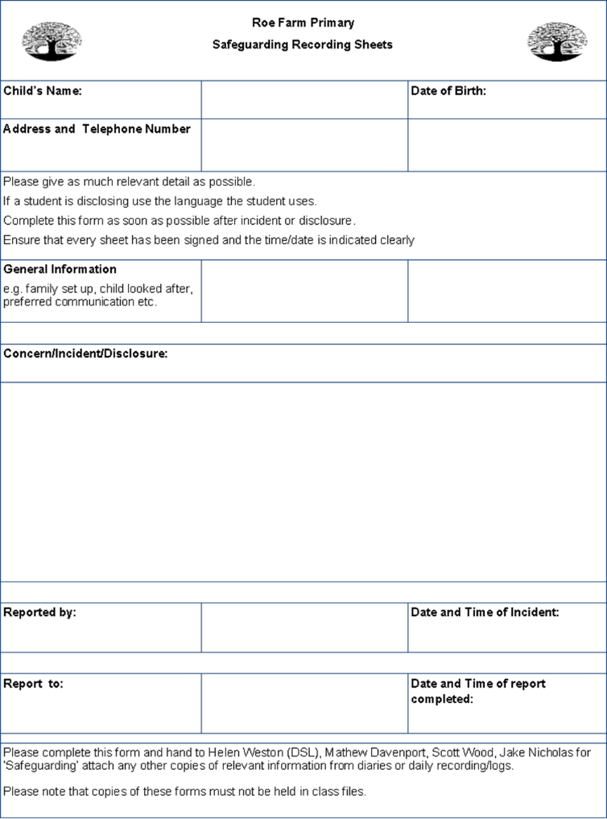

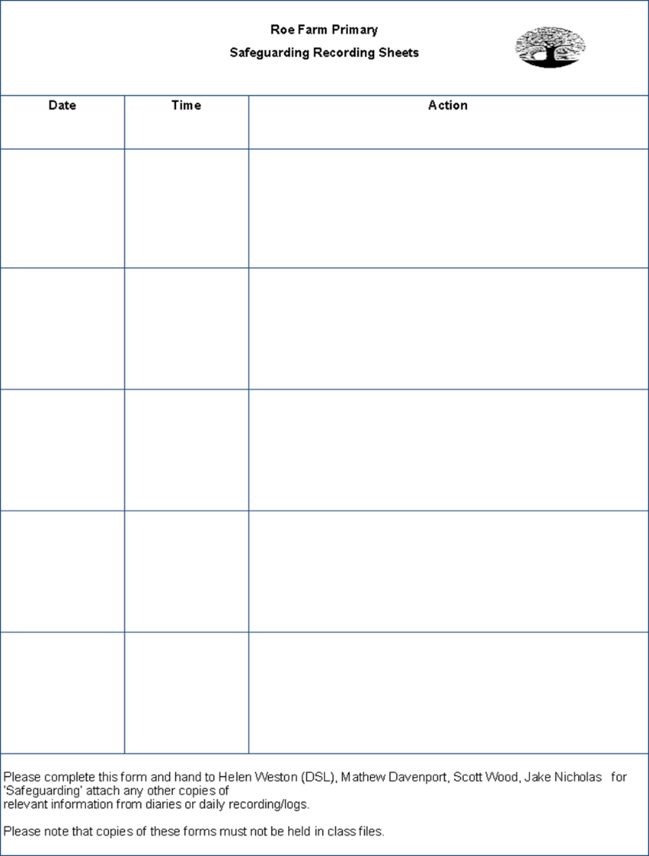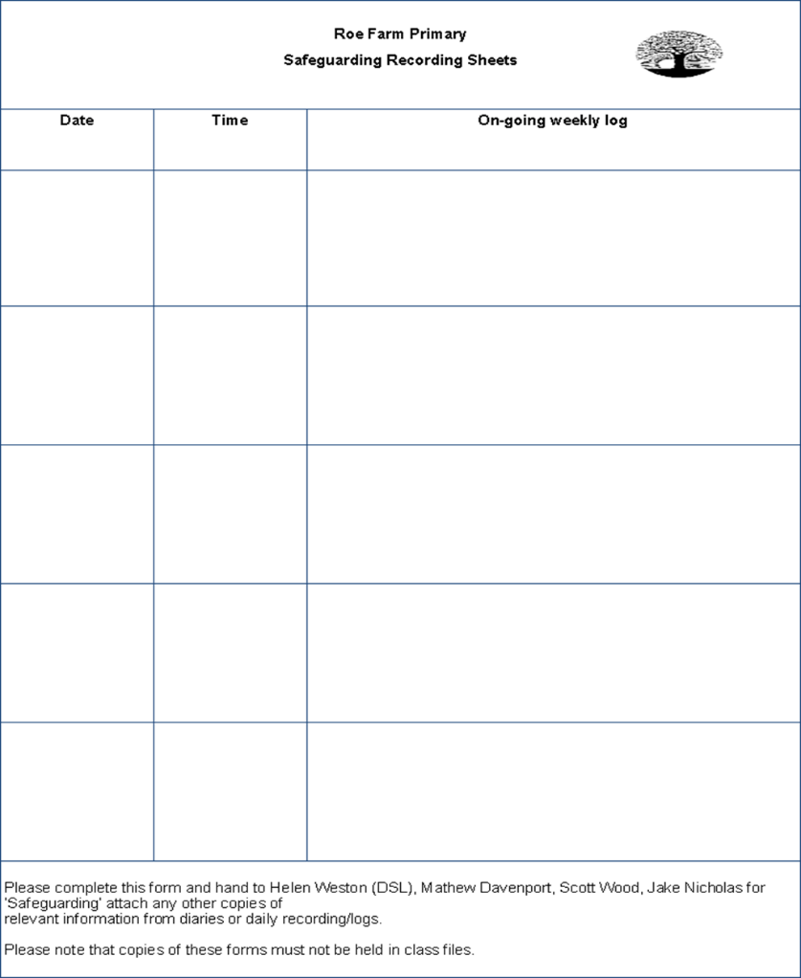
Appendix 3 Actions where there are concerns about a child

Taken from Keeping Children Safe in Education (2019) page 16
Appendix 4 Body Maps

Medical assistance and first aid should be sought where this is required.

All concerns and actions must be recorded using the concerns form or other safeguarding recording systems in use within the setting.

Body Maps should be used to document and illustrate visible signs of harm and physical injuries. They must be completed at time of observation using a black pen; correction fluid or any other eraser should not be used.

Do not:
- Remove or lift clothing for the purpose of the examination unless the injury site is freely available because of treatment, or;
- Take photos of injuries. If photos of injuries are required for evidence purposes then this should be done by the Police.
Do:
Record any visible injuries or ask the child/young person to point to where else it is sore/hurts

When you notice an injury to a child, try to record the following information in respect of each mark identified e.g. red areas, swelling, bruising, cuts, lacerations and wounds, scalds and burns:
- Exact site of injury on the body, e.g. upper outer arm/left cheek
- Size of injury - in appropriate centimetres or inches
- Approximate shape of injury, e.g. round/square or straight line
- Colour of injury - if more than one colour, say so
- Is the skin broken?
- Is there any swelling at the site of the injury, or elsewhere?
- Is there a scab/any blistering/any bleeding?
- Is the injury clean or is there grit/fluff etc.?
- Is mobility restricted as a result of the injury?
- Does the site of the injury feel hot?
- Does the child feel hot?
- Does the child feel pain?
- Has the child’s body shape changed/are they holding themselves differently?

Importantly the date and time of the recording must be stated as well as the name and designation of the person making the record. Add any further comments as required.

A copy of the body map should be kept on the child/young person’s safeguarding/child protection file.
Body Map

Name of Child: |  | Date of Birth:
Name of person completing the Body Map: |  | Role:
Date and time of observation:

Name of Child: |  | Date/time of observation:
FRONT |  | BACK
 |  | 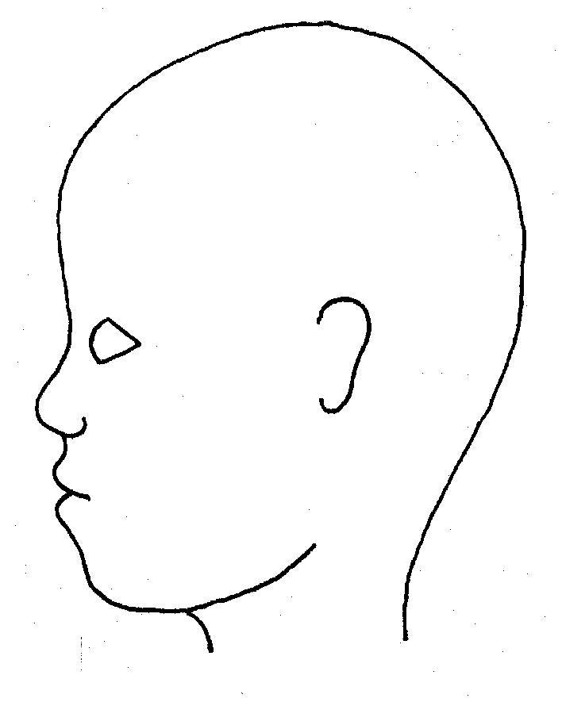
RIGHT |  | LEFT

Name of Child: |  | Date/time of observation:
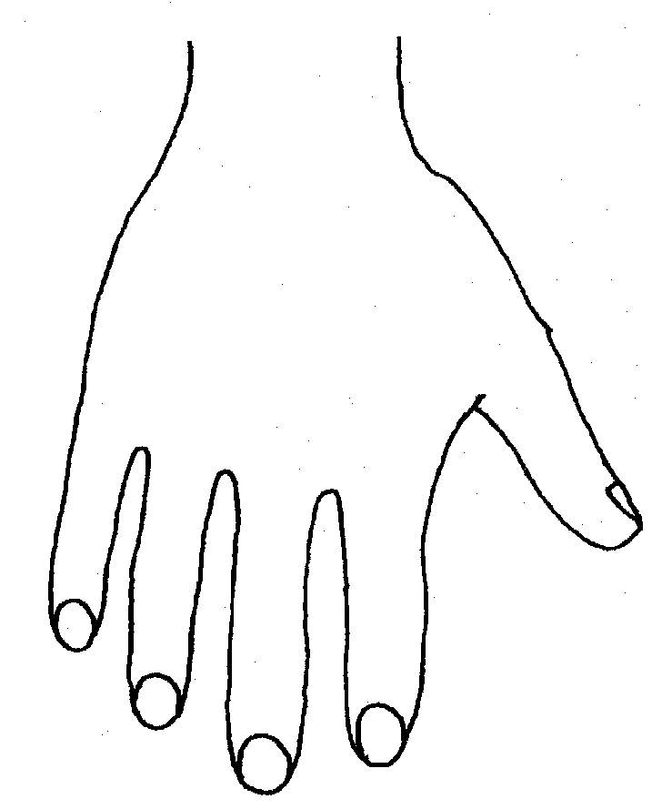 |  | 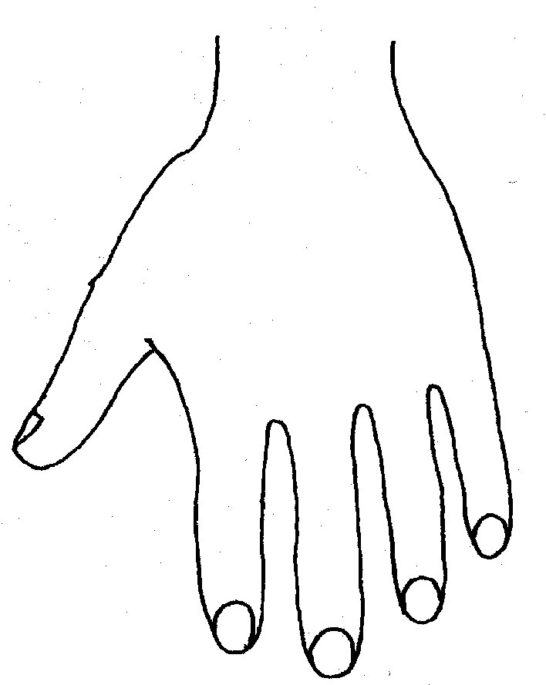
RIGHT |  | LEFT
BACK
RIGHT |  | LEFT
PALM

 | Name of Child: |  |  |  |  |  | Date/time of observation:
RIGHT |  | TOP |  |  | LEFT | RIGHT |  |  | BOTTOM |  |  | LEFT
RIGHT |  |  |  |  |  | LEFT
INNER
RIGHT |  |  |  |  |  | LEFT
OUTER
Printed name |  |  |  |  |  |  |  | Date:
Signature |  |  |  |  |  |  |  | Time:

Appendix 5
What is Domestic Abuse, and so called ‘Honour Based Abuse/Violence’ (HBA/HBV) including Female Genital Mutilation (FGM) and Forced Marriage?

Domestic Abuse
The cross-government definition of domestic violence and abuse is: ‘any incident or pattern of incidents of controlling, coercive, threatening behaviour, violence or abuse between those aged 16 or over who are, or have been, intimate partners or family members regardless of gender or sexuality. The abuse can encompass, but is not limited to:
- psychological
- physical
- sexual
- financial
- emotional’

Controlling behaviour
Controlling behaviour is a range of acts designed to make a person subordinate and/or dependent by isolating them from sources of support, exploiting their resources and capacities for personal gain, depriving them of the means needed for independence, resistance and escape and regulating their everyday behaviour.

Coercive behaviour
Coercive behaviour is an act or a pattern of acts of assault, threats, humiliation and intimidation or other abuse that is used to harm, punish, or frighten their victim.

Domestic abuse is a crime and should be reported to the Police.

Children may suffer both directly and indirectly if they live in households where there is domestic abuse. Exposure to domestic abuse and/or violence can have a serious, long lasting emotional, physical, developmental and psychological impact on children. In some cases, a child may blame themselves for the abuse or may have had to leave the family home as a result. Domestic abuse affecting young people can also occur within their personal relationships, as well as in the context of their home life.

Children living in families where they are exposed to abuse have been shown to be at risk of behavioural, emotional, physical, cognitive functioning, attitudes and long term developmental problems. They may:
- become aggressive
- display anti-social behaviour
- suffer from depression or anxiety
- not do as well at school due to difficulties at home or disruption of moving to and from refuges.

Incidents of domestic abuse towards pregnant women are associated with poor obstetric outcomes in a number of ways, such as increased rates of miscarriage, premature birth, low birth weight, foetal injury and foetal death.

All concerns about domestic abuse must be reported to the Designated Safeguarding Lead or their deputy

Also see DDSCP safeguarding children procedures; Domestic Abuse.
Honour Based Abuse/Violence
Honour based abuse (HBA) or violence (HBV) can be described as a collection of practices, which are used to control behaviour within families or other social groups to protect perceived cultural and religious beliefs and/or honour. Such violence can occur when perpetrators perceive that a relative has shamed the family and/or community by breaking their honour code.

It is a violation of human rights and may be a form of domestic and/or sexual violence. Where it affects children and young people it is child abuse.

It can be distinguished from other forms of abuse and violence, as it is often committed with some degree of approval and/or collusion from family and/or community members. Women, men and younger members of the family can all be involved in the abuse. Victims of honour-based abuse are more likely to be abused multiple times by multiple perpetrators.

Honour based abuse and violence manifests itself in a diverse range of ways with children and young people, it can lead to a deeply embedded form of coercive control, built on expectations about behaviour that are made clear at a young age. Often the control is established without obvious violence for instance through family members threatening to kill themselves because of the victim’s behaviour. Honour based abuse can also include forced marriage (approximately 1 in 5 cases), domestic and/or sexual violence, rape, physical assaults, harassment, kidnap, threats of violence (including murder), witnessing violence directed towards a sibling or indeed another family member, and female genital mutilation.

Do not underestimate the potential risk of harm

One Chance Rule
All staff working with suspected or actual victims of forced marriage and honour-based violence need to be aware of the "one chance" rule. That is, they may only have one opportunity to speak to a victim or potential victim and may possibly only have one chance to save a life.

If the victim is allowed to leave without the appropriate support and advice being offered, that one chance might be wasted.

All concerns about ‘honour based’ abuse/violence must immediately be reported to the Designated Safeguarding Lead or their deputy

Also see DDSCP safeguarding children procedures; Honour Based Abuse and Violence (HBA/HBV).

Female Genital Mutilation
Female Genital Mutilation (FGM) is a form of child abuse and violence against female children and women, a serious public health concern and a human rights issue.

The World Health Organisation (WHO) defines female genital mutilation as ‘all procedures (not operations) which involve partial or total removal of the external female genitalia or injury to the female genital organs whether for cultural or other non-therapeutic reasons.’

It is illegal in the UK to subject a female child or woman to female genital mutilation (FGM), to take a child abroad to undergo FGM or for any person to advise, help or force a female child to inflict FGM on herself. It is also an offence to fail to protect a female child from the risk of FGM.

FGM can be carried out at any age and is performed for a variety of complex reasons with a range of explanations and motives given by individuals and families who support the practice. It is medically unnecessary, is extremely painful, terrifying and has life threatening physical and serious psychological health consequences both at the time the procedure is carried out and later in life.

FGM may be an isolated incident of abuse within a family however it can be associated with other behaviours that discriminate against, limit or harm female children and women. These may include 'honour' based violence, forced marriage and domestic abuse.

Staff should also be aware that some female children and women at risk may not yet be aware of the practice or that it may have conducted on them.

Identifying risk of FGM
The most significant factor to consider when deciding whether a female child or woman may be at risk of FGM is whether her family has a history of practising FGM. In addition it is important to consider whether FGM is known to be practised in her community or county of origin. Women may also marry into practising communities and then have to go through FGM. Alongside a female child or woman's community or country of origin there are a range of other factors that could indicate a risk that she will be subjected to FGM. These include:

- A female child is born to a woman who has undergone FGM;
- A female child has an older sibling or cousin who has undergone FGM;
- A female child's father comes from a community known to practise FGM;
- The family indicate that there are strong levels of influence held by elders and/or elders are involved in bringing up female children;
- A woman/family believe FGM is integral to cultural or religious identity;
- Female child/family has limited levels of integration within UK community;
- Parents have limited access to information about FGM and do not know about the harmful effects of FGM or UK law;
- A family is not engaging with professionals (health, education or other);
- A family is already known to Social Care in relation to other safeguarding issues;
- Any female child from a practising community withdrawn from Sex and Relationships Education or its equivalent as a result of her parents wishing to keep her uninformed about her body and rights;
- Parents seeking to withdraw their children from learning about FGM;
- Sections are missing from a female child's health red book (parent held record).

Indications FGM may be imminent
Consider factors above and specifically the points below:

- If a family elder is present, particularly if she is visiting from a country of origin, and taking a more active/influential role in the family;
- If there are references to FGM in conversation, e.g. a female child may tell other children about it or confide that she is about to have a 'special procedure' or to attend a special occasion to 'become a woman;
- Parents state that they or a relative will take the female child out of the country for a prolonged period. This may be discussed within the school environment or travel clinics when asking for vaccinations in preparation for travel;
- A female child may talk about a long holiday to her country of origin or another country where the practice is prevalent. See Appendix 4: International Prevalence of FGM (Documents Library, Other Useful Information) and Legislation Banning FGM;
- A female child may request help from a teacher or another adult if she is aware or suspects she is at risk;
- A female child is unexpectedly absent from school;
- A parent or family member expresses concerns that FGM may be carried out on the female child.

The above is not an exhaustive list of risk factors. There may be additional risk factors to specific communities e.g. in certain communities FGM is closely associated to when a female child reaches a particular age.

Indications that FGM has already taken place
There are a number of indications that a female child or woman has already been subjected to FGM. This includes a female child or woman:

- Asking for help;
- Experiencing difficulty walking, sitting or standing and may appear to be uncomfortable;
- Finding it hard to sit still for longer periods of time, and this was not a problem previously;
- Having frequent urinary, menstrual or stomach problems;
- Avoids physical exercise or requires to be excused from physical education (PE) without a GP's letter;
- Spending long periods of time away from the classroom during the day with bladder or menstrual problems;
- Having prolonged or repeated absences from school or college;
- Spending longer than normal in the toilet due to difficulties urinating;
- Increased emotional or psychological needs e.g. withdrawal or depression or significant change in behaviour;
- Talks about a pain or discomfort between her legs;
- Asking for help, but may not be explicit about the problem; and/or
- Being reluctant to undergo any medical examinations.
- A parent / other adult, a child or other children may also disclose that the child has been subjected to FGM.

‘Known’ case of female genital mutilation (FGM), in addition to a referral to Social Care, the individual teacher also has a mandatory reporting duty; see Section 4 Taking Action on Concerns, Referral to Children’s Social Care and Mandatory Reporting of Female Genital Mutilation; procedural information (2015).

For further information about FGM see DDSCP safeguarding children procedures; Safeguarding Children at Risk of Abuse through Female Genital Mutilation (FGM).

All concerns about female genital mutilation (FGM) must be reported to the Designated Safeguarding Lead or their deputy

Forced Marriage
A forced marriage is where one or both people do not (or in cases of people with learning disabilities, cannot) consent to the marriage and pressure or abuse is used. It is recognised in the UK as a form of domestic and/or sexual violence against women and men, and a serious abuse of human rights. Where it affects children and young people it is child abuse. Disabled children and young people are vulnerable to forced marriage. Circumstances may also be more complex if the child is lesbian, gay, bisexual or transgender.

It is a criminal offence to force someone to marry.

The pressure put on people to marry against their will can be physical (including threats, actual physical violence and sexual violence) or emotional and psychological (for example, when someone is made to feel like they’re bringing shame on their family). Financial abuse can also be a factor.

A clear distinction must be made between forced marriage and arranged marriage. In arranged marriages, the families of both spouses take a leading role in choosing the marriage partner, but the choice whether or not to accept the arrangements remains with the individual. Consent must be from both parties.

Children forced to marry, or those who fear they may be forced to marry, are frequently withdrawn from education, or have numerous absences, go missing, are not allowed to attend extra-curricular activities or subjected other unreasonable restrictions, appear to have low motivation at school, restricting their educational attainment and personal development. They may feel unable to go against the wishes of their parents and consequently may suffer emotionally, with feelings of betrayal and shame that can lead to depression and self-harm.

A child may also approach a member of staff because they are concerned about forced marriage. It may involve going on a family holiday overseas or in the UK and the child may suspect that this is a ploy and that there is an ulterior motive, which is to force them to marry.

Do not underestimate the potential risk of harm

One Chance Rule
All staff working with suspected or actual victims of forced marriage and honour-based violence need to be aware of the "one chance" rule. That is, they may only have one opportunity to speak to a victim or potential victim and may possibly only have one chance to save a life.

If the victim is allowed to leave without the appropriate support and advice being offered, that one chance might be wasted.

All concerns about forced marriage must immediately be reported to the Designated Safeguarding Lead or their deputy

Also see DDSCP safeguarding children procedures; Forced Marriage.

Appendix 6 Privately Fostered Children or Young People

Definition of private fostering
A private fostering arrangement is a private arrangement for a child under the age of 16 (or 18 if they are disabled) to be cared for by someone who is not a parent or close relative for more than 28 days. The Local Authority is not involved in placing the child or young person in this private arrangement.

A child or young person is privately fostered if they are living with extended family members such as cousins, great aunts, great uncles or a family friend. They may be living outside of their parents care due to;
- Child or young person is asked to leave the family home
- Parent is in prison / hospital / homeless
- To avoid becoming a looked after child
- Parent has left the local area and child has remained to complete academic studies
- Child leaves due to family dysfunction or because they have been living with parents who have substance misuse problems or other difficulties
- Parent decides to place child with extended family member
- Child is placed with extended family for religious or economic reasons

Responsibilities
Private foster carers are responsible for providing the day-to-day care of the child in a way which will promote and safeguard his welfare. However, the overarching responsibility remains with the person who has parental responsibility for the child.

The Local Authority has legal duties towards private fostered children / young people and must satisfy itself that welfare of children who are, or will be, privately fostered within their area are satisfactorily safeguarded.

If you or your agency become aware of a child or young person living in a private fostering arrangement you must notify the Local Authority Children’s Social Care by telephone in one working day and you will be asked to follow this up in writing. Children’s Social Care can be contacted via the First Contact Team, 01332 641172.

For further information about how to make a referral to Children’s Social Care, please see the DDSCP Safeguarding Children procedures.These can also be found on the local safeguarding children procedures and guidance page of www.ddscp.org.uk.

See Private Fostering flowchart on the following page and DDSCP Private Fostering webpage.

All concerns about private fostering arrangements must be reported to the Designated Safeguarding Lead or their deputy

Is this a Privately Fostered Child or Young Person?
Is the child living with their parents?
Are they a looked after child / young person or living with someone else who as PR e.g. Residence Order?

Not private fostering
Yes
No
Are they aged over 16 or 18 if disabled?

Are they living with a close relative (e.g. step parent by marriage, grandparent, brother, sister, aunt or uncle)?

Has the child or young person been living there for more than 28 days, or the plan is for them to live there for 28 days or more?
This is a private fostering arrangement and the child or young person is classified as a Child In Need
You must refer the child or young person to Children’s Social Care

Yes
No
Yes
No
No
Yes
Yes
No

Appendix 7 Radicalisation and Extremism

In order for the school to fulfil the Prevent Duty, it is essential that staff are able to identify children who are vulnerable to radicalisation and know what to do when they are identified.

What is Radicalisation and Extremism?
Radicalisation is defined as the process by which a person comes to support terrorism and forms of extremism leading to terrorism. During this process it is possible to intervene to prevent vulnerable people being drawn into terrorist related activity.

Extremism is vocal or active opposition to fundamental British values, including democracy, the rule of law, individual liberty and mutual respect and tolerance of different faiths and beliefs. We also include in our definition of extremism calls for the death of members of our armed forces, whether in this country or overseas. Terrorist groups very often draw on extremist ideas developed by extremist organisations.

Taken from:
The Prevent Duty – departmental advice for schools and childcare providers (2015)

Identification
There is no single way of identifying a child or young person who is likely to be susceptible to radicalisation.

However to issues that may make an individual vulnerable to radicalisation, can include:
- Identity Crisis - distance from cultural / religious heritage and uncomfortable with their place in the society around them;
- Personal Crisis - family tensions; sense of isolation; adolescence; low self-esteem; disassociating from existing friendship group and becoming involved with a new and different group of friends; searching for answers to questions about identity, faith and belonging;
- Personal Circumstances - migration; local community tensions; events affecting country or region of origin; alienation from UK values; having a sense of grievance that is triggered by personal experience of racism or discrimination or aspects of Government policy;
- Unmet aspirations - perceptions of injustice; feeling of failure; rejection of community values;
- Criminality - experiences of imprisonment; previous involvement with criminal groups.

As with managing other safeguarding risks, all staff should be alert to changes in children’s behaviour which could indicate they may be in need of help or protection. Children at risk of radicalisation may display different signs or seek to hide their views. Changes may include:
- General changes of mood, patterns of behaviour, secrecy;
- Changes of friends and mode of dress;
- Use of inappropriate language;
- Narrow/limited religious or political view;
- Attendance at certain meetings e.g. rallies and articulating support for;
- "Them" and "us" language/rhetoric;
- Sudden unexplained foreign travel;
- Possession of violent extremist literature;
- The expression of extremist views;
- Advocating violent actions and means;
- Association with known extremists;
- Seeking to recruit others to an extremist ideology.

As with managing other safeguarding risks, staff should be alert to changes in children’s behaviour which could indicate they may be in need of help or protection.

All concerns should be reported to the Designated Safeguarding Lead or their deputy

See DDSCP safeguarding children procedures; Safeguarding Children and Young People against Radicalisation and Violent Extremism.

Appendix 8 Criminal Child Exploitation, including county lines

Criminal exploitation of children is a geographically widespread form of harm that is a typical feature of county lines criminal activity: drug networks or gangs groom and exploit children and young people to carry drugs and money from urban areas to suburban and rural areas, market and seaside towns.

The UK Government defines county lines as:
‘County lines is a term used to describe gangs and organised criminal networks involved in exporting illegal drugs into one or more importing areas within the UK, using dedicated mobile phone lines or other form of “deal line”. They are likely to exploit children and vulnerable adults to move and store the drugs and money and they will often use coercion, intimidation, violence (including sexual violence) and weapons.’

Child criminal exploitation is used to describe this type of exploitation where children are involved and similar to CSE is defined as:

Child Criminal Exploitation is common in county lines and occurs where an individual or group takes advantage of an imbalance of power to coerce, control, manipulate or deceive a child or young person under the age of 18. The victim may have been criminally exploited even if the activity appears consensual.

Child Criminal Exploitation does not always involve physical contact; it can also occur through the use of technology. Criminal exploitation of children is broader than just county lines, and includes for instance children forced to work on cannabis farms or to commit theft.

See Criminal exploitation of children and vulnerable adults: county lines (2018) Home Office and Preventing youth violence and gang involvement (2015) Home Office.

Like other forms of abuse and exploitation, county lines exploitation:

- can affect any child or young person (male or female) under the age of 18 years;
- can affect any vulnerable adult over the age of 18 years;
- can still be exploitation even if the activity appears consensual;
- can involve force and/or enticement-based methods of compliance and is often accompanied by violence or threats of violence;
- can be perpetrated by individuals or groups, males or females, and young people or adults; and Is typified by some form of power imbalance in favour of those perpetrating the exploitation.

Whilst age may be the most obvious, this power imbalance can also be due to a range of other factors including gender, cognitive ability, physical strength, status, and access to economic or other resources.

All concerns should be reported to the Designated Safeguarding Lead or their deputy

Also see:
DDSCP safeguarding children procedures; Children at Risk of Exploitation (CRE)
Criminal Exploitation of children and vulnerable adults: County Lines guidance (2018), Home Office
Appendix 9 The Seven Golden Rules to Sharing Information

- Remember that the General Data Protection Regulation (GDPR), Data Protection Act 2018 and human rights law are not barriers to justified information sharing, but provide a framework to ensure that personal information about living individuals is shared appropriately.

- Be open and honest with the individual (and/or their family where appropriate) from the outset about why, what, how and with whom information will, or could be shared, and seek their agreement, unless it is unsafe or inappropriate to do so.

- Seek advice from other practitioners, or your information governance lead, if you are in any doubt about sharing the information concerned, without disclosing the identity of the individual where possible.

- Where possible, share information with consent, and where possible, respect the wishes of those who do not consent to having their information shared. Under the GDPR and Data Protection Act 2018 you may share information without consent if, in your judgement, there is a lawful basis to do so, such as where safety may be at risk. You will need to base your judgement on the facts of the case. When you are sharing or requesting personal information from someone, be clear of the basis upon which you are doing so. Where you do not have consent, be mindful that an individual might not expect information to be shared.

- Consider safety and well-being: base your information sharing decisions on considerations of the safety and well-being of the individual and others who may be affected by their actions.

- Necessary, proportionate, relevant, adequate, accurate, timely and secure: ensure that the information you share is necessary for the purpose for which you are sharing it, is shared only with those individuals who need to have it, is accurate and up-to-date, is shared in a timely fashion, and is shared securely (see principles).

- Keep a record of your decision and the reasons for it – whether it is to share information or not. If you decide to share, then record what you have shared, with whom and for what purpose.

Taken from Information Sharing: advice for practitioners providing safeguarding services to children, young people, parents and carers (2018) HM Government

Appendix 10 Role of the Designated Safeguarding Lead (DSL) and Deputy

Governing bodies, proprietors and management committees should appoint an appropriate member of staff, from the school or college leadership team, to take the role of designated safeguarding lead. The designated safeguarding lead should take lead responsibility for safeguarding and child protection (including online safety). This should be explicit within the role-holders job description. This person should have the appropriate status and authority within the establishment to carry out the duties of the post. They should be given the time, funding, training, resources and support to provide advice and support to other staff on child welfare and child protection matters, to take part in strategy discussions and inter-agency meetings and/or to support other staff to do so and to contribute to the assessment of children.

Deputy designated safeguarding leads
It is a matter for individual schools and colleges as to whether they choose to have one or more deputy designated safeguarding lead/s. Any deputies should be trained to the same standard as the designated safeguarding lead and the role should be explicit in their job description.

Whilst the activities of the designated safeguarding lead can be delegated to appropriately training deputies, the ultimate lead responsibility for child protection, as set out above, remains with the designated safeguarding lead; this lead responsibility should not be delegated.

The designated safeguarding lead is expected to:

Manage referrals
- Refer cases of suspected abuse to the local authority Children’s Social Care as required;
- Support staff who make referrals to local authority children’s social care;
- Refer cases to the Channel programme where there is a radicalisation concern as required;
- Support staff who make a referrals to the Channel programme;
- Refer cases where a person is dismissed or left due to risk/ harm to a child to the Disclosure and Barring Service as required; and
- Refer cases where a crime may have been committed to the Police as required.

Work with others
- Act as a point of contact with the three safeguarding partners;
- Liaise with the headteacher or principal to inform him or her of issues especially on-going enquiries under section 47 of the Children Act 1989 and police investigations;
- As required, liaise with the case manager and designated officers at the local authority (also known as local authority designated officer/LADO) for child protection concerns (all cases which concern a staff member); and
- Liaise with staff (especially pastoral support staff, school nurses, IT Technicians, and SENCOs or the named person with oversight for SEN in a college) on matters of safety and safeguarding (including online and digital safety) and when deciding whether to make a referral by liaising with relevant agencies.
- Act as a source of support, advice and expertise for staff.

Training
The Designated Safeguarding Lead (and any deputies) should undergo training to provide them with the knowledge and skills required to carry out the role. This training should be updated at every two years. The designated safeguarding lead should undertake Prevent awareness training.

In addition to the formal training set out above, their knowledge and skills should be refreshed (this might be via e-bulletins, meeting other designated leads, or simply taking time to read and digest safeguarding developments) at regular intervals, as required, but at least annually, to allow them to understand and keep up with any developments relevant to their role so they:

- Understand the assessment process for providing early help and intervention, including local criteria for action and local authority children’s social care referral arrangements;
- Have a working knowledge of how local authorities conduct a child protection case conference and a child protection review conference and be able to attend and contribute to these effectively when required to do so;
- Ensure each member of staff has access to and understands the school’s or college’s child protection policy and procedures, especially new and part time staff;
- Be alert to the specific needs of children in need, those with special educational needs or a disability and young carers;
- Understand relevant data protection legislation and regulations, especially the Data Protection Act 2018 and the General Data Protection Regulation;
- Understand the importance of information sharing, both with the school and college, and with the three safeguarding partners, other agencies, organisations and practitioners;
- Be able to keep detailed, accurate, secure written records of concerns and referrals;
- Understand and support the school or college with regards to the requirements of the Prevent duty and are able to provide advice and support to staff on protecting children from the risk of radicalisation;
- Are able to understand the unique risks associated with online safety and be confident that they have the relevant knowledge and up to date capability required to keep children safe whilst they are online at school or college;
- Can recognise the additional risks that children with SEN and disabilities (SEND) face online, for example, from online bullying, grooming and radicalisation and are confident they have the capability to support SEND children to stay safe online;
- Obtain access to resources and attend any relevant or refresher training courses; and
- Encourage a culture of listening to children and taking account of their wishes and feelings, among all staff, in any measures the school or college may put in place to protect them.

Raise awareness
- The designated safeguarding lead should ensure the school or college’s policies are known, understood and used appropriately;
- Ensure the school or college’s child protection policy is reviewed annually (as a minimum) and the procedures and implementation are updated and reviewed regularly, and work with governing bodies or proprietors regarding this;
- Ensure the child protection is available publicly and parents are aware of the fact that referrals about suspected abuse or neglect may be made and the role of the school or college in this; and
- Link with the safeguarding partner arrangements to make sure staff are aware of training opportunities and the latest local policies on safeguarding.

Child protection file
- Where children leave the school or college ensure their child protection file is transferred to the new school or college as soon as possible. This should be transferred separately from the main pupil file, ensuring secure transit and confirmation of receipt should be obtained. Receiving schools and colleges should ensure key staff such as designated safeguarding leads and SENCOs or the named person with oversight for SEN in colleges, are aware as required.
- In addition to the child protection file, the designated safeguarding lead should also consider if it would be appropriate to share any information with the new school or college in advance of a child leaving. For example, information that would allow the new school or college to continue supporting victims of abuse and have that support in place for when the child arrives.

Availability
- During term time the designated safeguarding lead (or a deputy) should always be available (during school or college hours) for staff in the school or college to discuss any safeguarding concerns. Whilst generally speaking, the designated safeguarding lead (or deputy) would be expected to be available in person, it is a matter for individual schools and colleges, working with their designated safeguarding lead to define what “available” means and whether in exceptional circumstances availability via phone and/or Skype or other such medium is acceptable.

- It is matter for individual schools and colleges and the designated safeguarding lead to arrange adequate and appropriate cover arrangements for any out of hours/out of term activities.
Taken from Keeping Children Safe in Education (2019), pages 92 to 95
Appendix 11 Guidance/Further Information

Local safeguarding information

Key local information about safeguarding children is located on Derby and Derbyshire Safeguarding Children Partnership website (www.ddscpscb.org.uk).

This includes Derby and Derbyshire Safeguarding Children Partnership safeguarding children procedures. Key chapters’ include:

- Providing early help
- Making a referral to children’s social care
- Child protection section 47 enquiries
- Child protection conferences
- Children who present a risk of harm to others
- Children abused through sexual exploitation
- Safeguarding children at risk of abuse through female genital mutilation (FGM)
- Safeguarding children and young people against radicalisation and violent extremism
- Allegations against staff carers and volunteers
- Runaway or Missing from Home or Care Protocol

The procedures also have key guidance document and information, including:
- Derby and Derbyshire Thresholds document
- Derby and Derbyshire Escalation policy and process
- DDSCP Information Sharing Guidance for Practitioners
- Derby Assessment Protocol
- Derby Child Protection Conference Professional Dissent Process
- Local contacts

The DDSCP website has a specific page for education providers, including a safeguarding children audit tool for schools and colleges to support schools their annual review of safeguarding practice and in their development of a safeguarding action plan. There is also a training pathway for education providers, template polices and information about the DDSCP Derby Education Hub and safeguarding update service.

There is a range of useful information and resources on the website, including:
- Private Fostering
- Domestic Abuse, including the domestic violence risk identification matrix (DVRIM)
- Early Help, including how to use the Early Help Assessment, forms and support
- Neglect, including graded care profile guidance and assessment tool template
- Child at Risk of Exploitation, including the Child at Risk of Exploitation (CRE) risk assessment toolkit
- Missing Children
- Online Abuse
- Safeguarding Training Courses and Events
- Safeguarding Forms and Assessments

Other sources of safeguarding information and guidance can be obtained via:
- www.gov.uk/schools-colleges-childrens-services/safeguarding-children
- www.nspcc.org.uk
- www.tes.com
- www.minded.org.uk
- www.uea.ac.uk/ican/

See DDSCP Education providers training pathway on the training page of www.ddscp.org.uk
HM Government (2018) Working Together to Safeguard Children, page 103
Brandon et al., (2010) Building on the learning from Serious Case Reviews: A two year analysis of child protection database notifications 2007-2009, Department for Education, 2010
HM Government (March 2015) What to do if you’re worried a child is being abuse: advice for practitioners
Taken from DDSCP Private Fostering Briefing Note and Flowchart (2014)

